Financial Control System (FCS)
Accounts Payable Project.
System Specification
Filing Reference : | ISS/FCS2/TS.2/1
Document Title : | System Specification
Version : | 1.0
Prepared By : | Low Siew Heng
Approved By :
 | Howard Russon  Project Manager | Date
Authorised By :
 | Mike Fenton  Project Director | Date
 | Lian Wee Li  Admin. Manager | Date
©1993 ISS.  The information contained in this document is the property of ISS. The contents must not be reproduced, wholly or in part, for purposes other than for which it has been supplied, without the prior permission of ISS, or, if it has been furnished under contract to another party, as expressly authorised under that contract. ISS shall not be liable for any errors or omissions. | ISS
Document Reference : ISS/FCS2/TS.2/1
Version | Date | Author | Authorised by | Date
1.0 | 08/11/26 | Low Siew Heng
Financial Control System (FCS)
Accounts Payable Project.
System Specification
Distribution :
Name | Department | Organisation
Mike Fenton
Howard Russon
Lian Wee Li
Lim Swee Cheang
Low Siew Heng
Frank Jenkins
Er Geok Tin

Table of Contents.
1. INTRODUCTION. 1
1.1. Purpose. 1
1.2. Audience. 1
1.3. Organisation. 1
1.4. References. 1
2. OVERVIEW OF REQUIREMENTS. 2
2.1 System Interfaces. 2
2.2 System Functions. 2
3. SYSTEM OVERVIEW. 3
3.1 Processing Requirements. 3
3.2 Inputs. 3
3.3 Outputs. 4
4. SCREEN LAYOUTS. 4
4.1 Main Menu. 5
4.2 Supplier Maintenance Dialog Box. 12
4.3 Cost Centre Maintenance Dialog Box. 14
4.4 Vote Category Maintenance Dialog Box. 16
4.5 Currency Maintenance Dialog Box. 18
4.6 Professional Society Maintenance Dialog Box. 20
4.7 Purchase Orders Dialog Box. 21
4.8 Delivery Orders Dialog Box. 26
4.9 Invoices Dialog Box. 29
4.10 Credit / Debit Notes Dialog Boxes. 37
4.11 Cancellation of PO Items Dialog Box. 40
4.12 Claims/Payments Dialog Box. 44
4.13 Staff Travel Dialog Box. 52

Table of Contents.
4.14 Recoupment of Petty Cash Dialog Box. 55
4.15 Payments Dialog Boxes. 57
4.16 Funds Transfer Dialog Box. 61
4.17 Journal Adjustment Dialog Box. 63
4.18 Financial Year Budget Dialog Box. 66
4.19 Staff Information Dialog Box. 68
4.20 Common Dialog Box for Displaying List of Records. 70
5. REPORT FORMATS. 71
5.1 Purchase Order Transactions. 71
5.2 Received Invoice Transactions. 71
5.3 Petty Cash Transactions. 72
5.4 Claims/Expense Payment Transactions. 72
5.5 Claims for Professional Societies Subscription - Letter to Bursar's Office. 73
5.6 Claims for Subscription to Professional Societies Report. 73
5.7 Staff Travelling. 74
5.8 Unsettled Payable Accounts. 74
5.9 Vote Control Register. 75
5.10 Total Accumulated Expenditure. 75
5.11 Journal Adjustment Transactions. 76
5.12 Cancellation of POs Transactions. 76
5.13 Audit Trail reports. 77
5.14 Currency Exchange Rate. 77
6. SECURITY. 78
Appendix A : REPORT FORMATS.

1. INTRODUCTION.
The Institute of Systems Science (ISS) requires the development of a Financial Control System (FCS). This will involve the computerisation of the two major functions of the current manual system:
1. Invoice/Accounts Receivable; and
2. Accounts Payable.
The development is required to be undertaken in two stages. The first stage, to develop the Invoice/Accounts Receivable module has been completed. This project is required to undertake Stage 2 of the development, to develop the Accounts Payable module of the system. In addition, the project is required to undertake the enhancement of the existing module (Invoice / Accounts Receivable) to meet the new requirements.

1.1. Purpose.
The purpose of this document is to provide a system specification for the Accounts Payable module of the Financial Control System (FCS). This specification presents the system overview, the screen layouts and the report formats.

1.2. Audience.
The intended readers of this System Specification are:
1. The project team: This is to provide them with the detailed user requirements of the system to be developed.
2. Wee Li: She is required to review the specified requirements of the software in this document to ensure that all the user requirements are met.

1.3. Organisation.
A summary of the requirements for the Accounts Payable module are specified in Section 2. Section 3 describes the system overview.and Section 4 defines all the screen formats, menus and commands. All the report formats to be produced by the system are specified in Section 5. Finally, Section 6 describes the level of access permitted by each type of user.

1.4. References.
To fully understand the background to this project, the reader should also be familiar with:
1. FCS Accounts Payable Project Plan, reference ISS/FCS2/MP.1/1, version 1.0, dated 9 July 1993.
2. FCS Accounts Payable Quality Plan, reference ISS/FCS2/MQ.1/1, version 1.0, dated 3 March 1994.
3. FCS Accounts Payable User Requirement Specification, reference ISS/FCS2/TS.1/1, version 1.0, dated 14 October 1993.

2. OVERVIEW OF REQUIREMENTS.

2.1 System Interfaces.
Currently, the supplier details are maintained by the Inventory Control System (ICS) and the Vote category details are computerised by the FCS Invoice/Accounts Receivable module. These two systems are to be interfaced with the Accounts Payable module. In addition, the Purchasing system may be computerised and interfaced with this system. This system will enable users to check the status of a purchase requisition form that consists of a list of equipments/software to be purchased.
Apart from the above, a common Management Accounting System (MAS) proposed by NSTB is expected to be installed in 1995. Therefore the FCS system should be compatible as far as possible with MAS.

2.2 System Functions.
The following system functions are to be implemented in this system.
1. Production of the summary report of the Petty Cash flow.
2. Creation of purchase order records.
3. Processing of purchase orders to update the delivery order numbers.
4. Processing of purchase orders to update the invoice numbers for payment.
5. Creation of invoices (without purchase orders) received from creditors for payment.
6. Creation of claims and other expense payments transactions (without invoices). For these payments, the system shall automatically generate reference numbers.
7. Creation of credit/debit notes received from suppliers/creditors.
8. Automatic updating the funds of a Vote category that is committed.
9. Updating the actual cash payment made by the Bursar's Office to keep track of the actual cash flow of each vote.

3. SYSTEM OVERVIEW.
The Accounts Payable module of Financial Control System (FCS) performs the primary functions of accounts payable, as specified in the following subsections.

3.1 Processing Requirements.
1. Provides facilities for the maintenance of the database for new Vote categories.
2. Provides facilities for the maintenance of the database for new Cost Centres.
3. Provides facilities for the maintenance of the database for Currency exchange rates.
4. Provides facilities for the maintenance of the database for Suppliers/Creditors.
5. Provides facilities for the maintenance of the database for Approved Professional Societies.
6. Provides facilities for the funds transfer between Votes/Cost Centres.
7. Provides facilities for journal adjustment to the Votes.
8. Provides facilities for the user to update the funds of the Votes based on the monthly statement of account received from NUS.
9. Provides facilities to warn the user when the fund of a committed vote falls to a critically low level.
10. Provides facilities for the user to back up the database.
11. Provides facilities for the user to change the password.

3.2 Inputs.
The following inputs shall be processed by the system.
1. Allows entry of purchase order records.
2. Allows users to update the delivery order number for a purchase order upon receiving the goods delivered by the supplier.
3. Allows users to update the invoice number for a purchase order upon receiving the invoice from supplier.
4. Allows authorised users to cancel the purchased items once the items are confirmed to be unable to be supplied by the supplier.
5. Allows entry of claims and other expense payments.
6. Allows entry of petty cash transactions.
7. Allows entry of invoices (without purchase orders or delivery orders) received from suppliers/creditors.
8. Allows entry of credit/debit notes received from suppliers/creditors.
9. Allows users to update the actual cash payment made by the Bursar's office.

3.3 Outputs.
The following outputs shall be produced by the system.
1. Petty Cash Transactions Log that shall replace the manual Petty Cash Book.
2. Cash Flow / Budget Tracking report.
3. Purchase Order Transactions report.
4. Delivery Order Transactions report.
5. Received Invoice Transactions report.
6. Claims / Expense Payment Transactions report.
7. Claims for Subscription to Professional Societies report.
8. Letter to Bursar's Office for the claims of Professional Societies Subscription.
9. Staff Travelling report.
10. Unsettled Payable Accounts report.
11. Journal Adjustment Transactions report.
12. Cancellation of POs Transactions report.
13. Currency Exchange Rate report.
14. Audit Trail reports.
15. On-line Enquiry for the funds of Votes.

4. SCREEN LAYOUTS.
The screen Layouts are described in this section in the following order.
1. Main menu window of the Accounts Payable module of Financial Control System (FCS) that is used to select the system commands.
2. Supplier maintenance dialog box.
3. Cost Centre maintenance dialog box.
4. Vote Category maintenance dialog box.
5. Currency maintenance dialog box.
6. Professional Societies maintenance dialog box.
7. Dialog box for entering the purchase orders.
8. Dialog boxes for entering the delivery orders.
9. Dialog boxes for entering the invoices received from suppliers/creditors.
10. The dialog box for updating the cancellation of the purchased items.
11. Dialog box for entering the petty cash transactions.
12. Dialog boxes for entering the claim request and other expense payment transactions.
13. Dialog boxes for entering the staff travel expenses.
14. The dialog box for updating the petty cash reimbursement amount.
15. Dialog boxes for updating the actual cash payment made by NUS Bursar's Office.
16. The dialog box for transferring the funds between Votes/Cost Centres.
17. The dialog box for passing the journal adjustments to Votes.
18. Dialog box for entering the budget amount of each vote for each financial year.

4.1 Main Menu.
This menu provides all the commands of Accounts Payable model of FCS.
Figure 4.1.1: Accounts Payable Main Menu
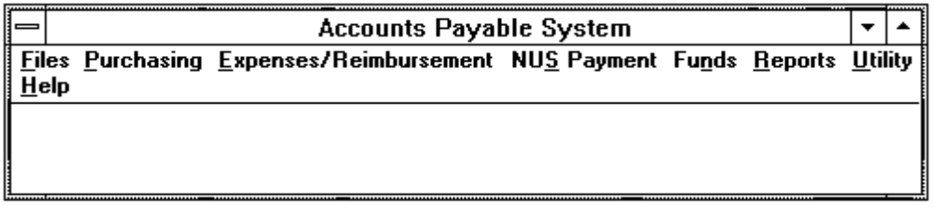

4.1.1 Files menu commands.
Controls the maintenance functions of the databases that are used by the Accounts Payable module of FCS.
Figure 4.1.2: Files Menu Commands
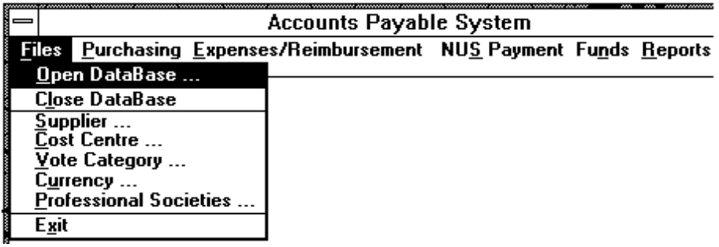
Open DataBase | To login to the SyBase server and open the database.
Close DataBase | To close the database and disconnect the SyBase server.
Supplier | To access the Supplier database. Refer to Section 4.2.
Cost Centre | To maintain the Cost Centre database. Refer to Section 4.3.
Vote Category | To maintain the Vote account database. Refer to Section 4.4.
Currency | To maintain the Currency database. Refer to Section 4.5.
Professional Societies | To maintain the Professional Society database. Refer to Section 4.6.
Exit | To close the application.

4.1.2 Purchasing menu command.
Provides the tools to enter the purchase order records upon preparing the purchase orders for suppliers. It also allows the users to update the details of delivery orders and invoices upon receiving the delivery orders/invoices from the suppliers/creditors.
Figure 4.1.3: Purchasing Menu Commands
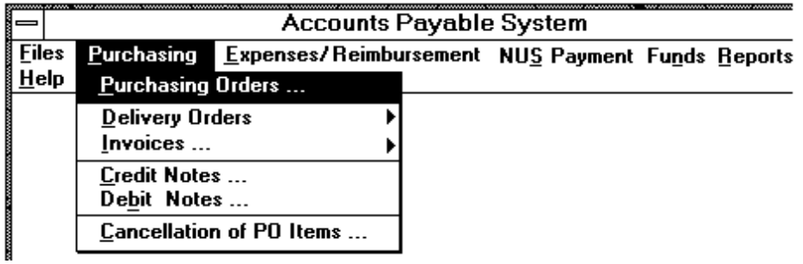
Purchase Orders | To allow the users to enter the purchase order records upon preparing the purchase orders for suppliers. Refer to Section 4.7.
Delivery Orders | To allow the users to update the details of delivery orders upon receiving the delivery orders from the suppliers. Refer to Section 4.8.
Invoices | To allow the users to enter the details of invoices upon receiving the invoices from the suppliers/creditors. Refer to Section 4.9.
Credit Notes | To allow the users to enter the details of credit note upon receiving the credit notes from the suppliers/creditors. Refer to Section 4.10.
Debit Notes | To allow the users to enter the details of debit note upon receiving the debit notes from the suppliers/creditors. Refer to Section 4.10.
Cancellation of PO Items | To allow the users to cancel some of the purchased items that are unable to be delivered by the supplier. Refer to Section 4.11.

4.1.3 Expenses/Reimbursement menu command.
Provides the tools to enter the claims requests and other expenses payments transactions.
Figure 4.1.4: Expenses/Reimbursement Menu Command
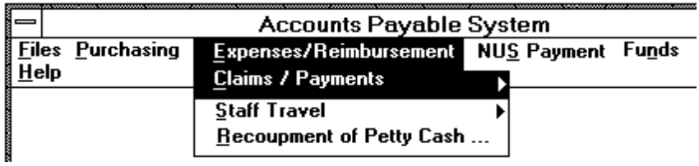
Claims/Payments | To provide the following options for the users to enter the claims requests and other expenses payment transactions.  • Thru Petty Cash  • Professional Society Subscription  • Other Expense Payments  Refer to Section 4.12.
Staff Travel | To provide the tools to enter the expenses incurred by staff travelling locally and overseas. Refer to Section 4.13.
Recoupment of Petty Cash | To allow the users to update the petty cash recoupment amount upon receiving petty cash from the NUS Bursar's Office. Refer to Section 4.14.

4.1.5 NUS Payment menu command.
Provides the tools for users to update the actual cash payment made by NUS Bursar's Office for each received invoice and expense payment created.
Figure 4.1.5: NUS Payment Menu Command
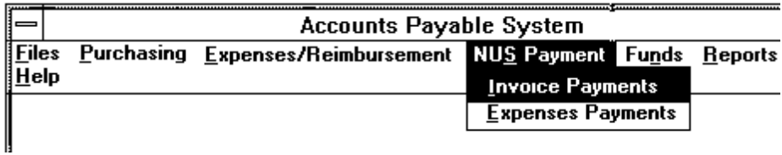
Invoice Payments | To allow the users to update the actual cash payment of each invoice received from the supplier. Refer to Section 4.15.
Expense Payments | To allow the users to update the actual cash payment of each expense payment created. Refer to Section 4.15.

4.1.6 Funds menu command.
Provides tools for the users to manipulate the records of funds held by ISS, such as funds transfer, journal adjustment, monthly expenses update and financial year budget entry.
Figure 4.1.6: Funds Menu Command
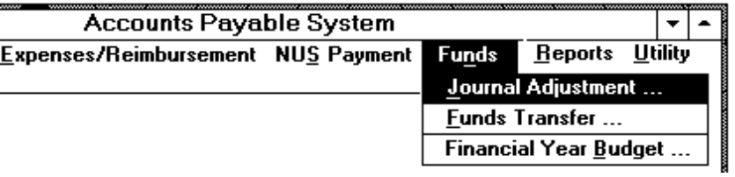
Journal Adjustment | To enable users to enter the journal adjustment of funds in each vote and update the monthly expenses paid directly by the NUS Bursar's Office. Refer to Section 4.17.
Funds Transfer | To enable the authorised users to transfer the funds between votes/cost centres. Refer to Section 4.16.
Financial Year Budget | To enable the authorised users to enter the budget for each vote. Refer to Section 4.18.

4.1.7 Reports menu command.
Allows the users to select the type of reports to be printed.
Figure 4.1.7: Reports Menu Command
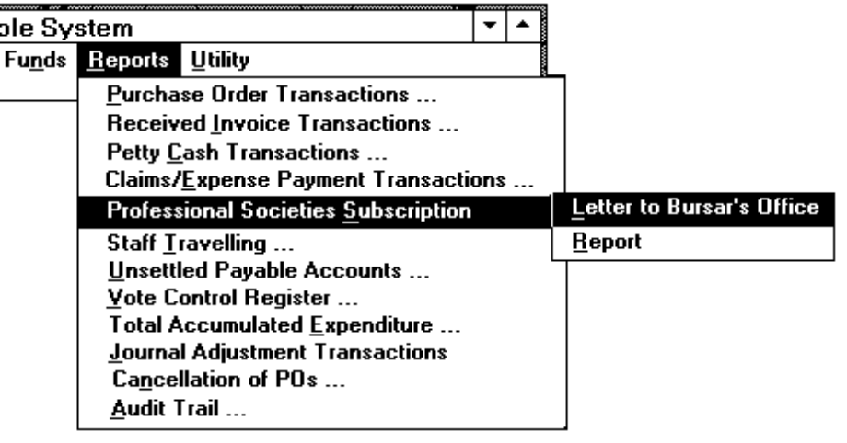
Purchase Order Transactions | To print a list of the purchase order transactions. Refer to Section 5.1.
Received Invoice Transactions | To print a list of the received invoice transactions. Refer to Section 5.2.
Petty Cash Transactions | To print a list of the petty cash transactions. Refer to Section 5.3.
Claims/Expense Payment Transactions | To print the claims/expense payment transactions report. Refer to Section 5.4.
Professional Societies Subscription | To print the following two reports:  • The claims letter to Bursar's Office. Refer to Section 5.5.  • The claims for Subscription to Professional Societies report in staff name order. Refer to Section 5.6.
Staff Travelling | To print the staff travelling report. Refer to Section 5.7.
Unsettled Payable Accounts | To print the unsettled payable accounts report. Refer to Section 5.8.
Vote Control Register | To print the Vote Control Register. Refer to Section 5.9.
Total Accumulated Expenditure | To print the total accumulated expenditure report for a specified period. Refer to Section 5.10.
Journal Adjustment Transactions | To print the journal adjustment transactions report. Refer to Section 5.11.
Cancellation of POs | To print the cancellation of POs transactions report. Refer to Section 5.12.
Audit Trail | To print a list of the amended/deleted records for audit purpose. Refer to Section 5.13.

4.1.8 Utility menu command.
Provides tools for backing up the database and accessing certain MS Windows applications.
Figure 4.1.8: Utility Menu Command
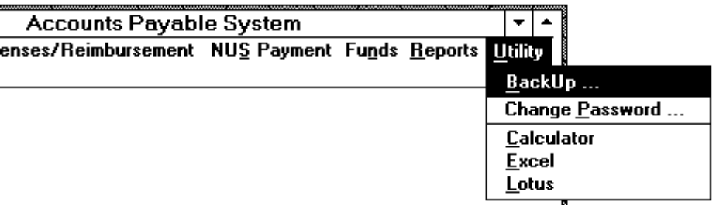
Backup | To allow users to backup the database.
Change Password | To allow users to change their password.
Calculator | To use the Calculator provided in MS Windows.
Excel | To provide access to MS Excel.
Lotus | To provide access to Lotus 123.

4.1.9 Help menu command.
Provides access to the on-line user guide.
Figure 4.1.9: Help Menu Command
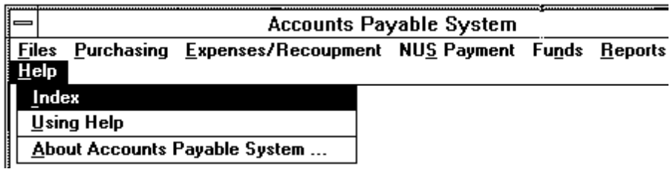
Index | To provide access to the index of the on-line user guide.
Using Help | To provide access to the on-line user guide.
About Accounts Payable System | To provide the following information:  • The software version of the Accounts Payable System  • The licenser of the Accounts Payable System.  • The system resource and the percentage of the free memory.

4.2 Supplier Maintenance Dialog Box.

4.2.1 Purpose.
Allows users to create new supplier records, and view, edit and delete the existing records. The supplier maintenance dialog box (Figure 4.2.1) is displayed when selecting the 'Supplier' command from the Files menu (see Section 4.1.2). The command menu displayed at the top of the dialog box is for the users to select the commands.

4.2.2 Command Menu.
View | To display the detailed information of the selected record.
Add | To create a new record.
Edit | To edit the selected record.
Delete | To delete the selected record.
Exit | To close the dialog box and quits the job.

4.2.3 Contents.
1. Supplier.
Source: Mandatory entry for 'Add' command. Displayed by the system for other commands.
Comment: It is used to display or enter the supplier's name. There are 40 characters provided. The system will check whether there is any duplicate supplier record. Please note that the supplier's name and address will be converted to upper case characters.
Figure 4.2.1: Supplier Maintenance Dialog Box
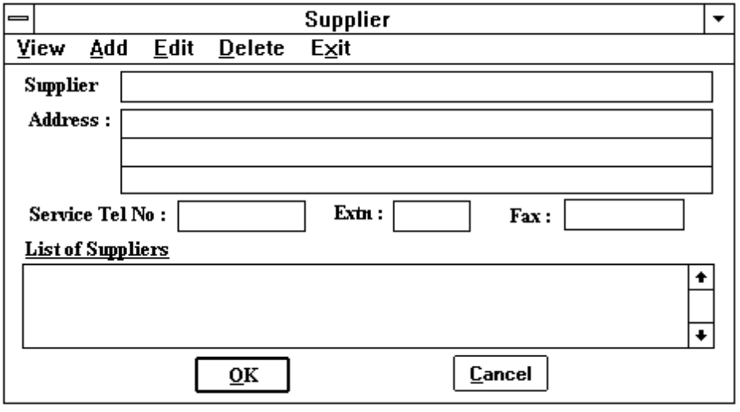
2. Address.
Source: Mandatory entry for both 'Add' and 'Edit' commands. Displayed by the system for other commands.
Comment: Three lines with 40 characters of the supplier's address are provided.
3. Service Tel No.
Source: Mandatory entry for both 'Add' and 'Edit' commands. Displayed by the system for other commands.
Comment: The contact telephone number of the supplier.
4. Extn.
Source: Mandatory entry for both 'Add' and 'Edit' commands. Displayed by the system for other commands.
Comment: The telephone extension number of the staff member to be contacted in the supplier company.
5. Fax.
Source: Mandatory entry for both 'Add' and 'Edit' commands. Displayed by the system for other commands.
Comment: The Fax number of the supplier company.
6. List of Suppliers.
Source: Displayed by the system.
Comment: All the supplier will be displayed for the users to select. This box is only applicable to view, edit and delete commands.
7. OK Button.
Source: It is used to confirm that the entries can be updated.
Comment: The entries will be updated if it is pressed.
8. Cancel Button.
Source: Optional push button. Used to cancel the job.
Comment: The entries will not be updated if the user presses this button.

4.2.4 Controls.
When using the Delete command, the following dialog box (Figure 4.2.2) is displayed for the user to confirm again whether the selected record should be deleted. The selected record will not be deleted until the user presses the 'Yes' button to confirm.
Figure 4.2.2: Confirmation Dialog Box
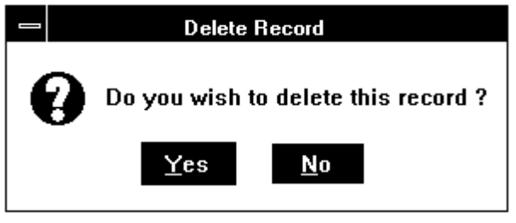

4.2.5 Error Messages.
1. This record already exits.

4.3 Cost Centre Maintenance Dialog Box.

4.3.1 Purpose.
Allows users to create new cost centres, view, edit and delete the existing cost centres. The cost centre maintenance dialog box (Figure 4.3.1) is displayed when selecting the 'Cost Centre' command from the Files menu (see Section 4.1.2). A command menu is always displayed at the top of the dialog box for the users to select the commands. For the details of the command menu, please refer to Section 4.2.2.

4.3.2 Contents.
1. Cost Centre List Box.
Source: Displayed by the system.
Comment: The description and code number for each cost centre will be displayed for the users to select.
Figure 4.3.1: Cost Centre Maintenance Dialog Box
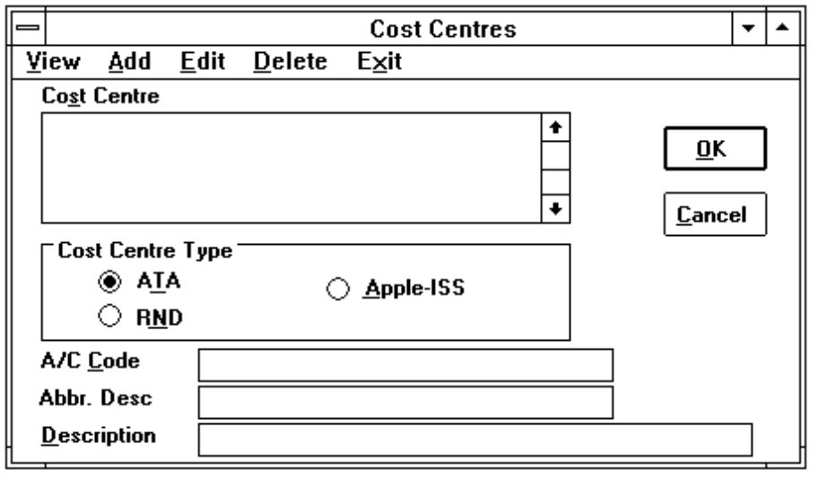
2. Cost Centre Type.
Source: Mandatory entry for both 'Add' and 'Edit' commands. Displayed by the system for other commands.
Comment: The default button is set at 'ATA' position.
3. A/C Code.
Source: Mandatory entry for both 'Add' and 'Edit' commands. Displayed by the system for other commands.
Comment: It is used to display or enter the cost centre account code.
4. Abbr. Desc.
Source: Mandatory entry for both 'Add' and 'Edit' commands. Displayed by the system for other commands.
Comment: Used to display or enter the abbreviation description of the cost centre. There are 20 characters provided.
5. Description.
Source: Mandatory entry for both 'Add' and 'Edit' commands. Displayed by the system for other commands.
Comment: It is used to display or enter the description of the cost centre. There are 40 characters provided.
6. OK Button.
As described in Section 4.2.3 item 7.
7. Cancel Button.
As described in Section 4.2.3 item 8.

4.3.3 Controls.
As described in Section 4.2.4.

4.3.4 Error Messages.
1. Please enter the Cost Centre Name !
2. Please enter the Cost Centre A/C No. !

4.4 Vote Category Maintenance Dialog Box.

4.4.1 Purpose.
Allows users to create new vote categories, view, edit and delete the existing vote categories. The vote category maintenance dialog box (Figure 4.4.1) is displayed when selecting the 'Vote Category' command from the Files menu (see Section 4.1.2). A command menu is always displayed at the top of the dialog box for the users to select the commands. For the details of the command menu, please refer to Section 4.2.2.
Figure 4.4.1: Vote Category Maintenance Dialog Box
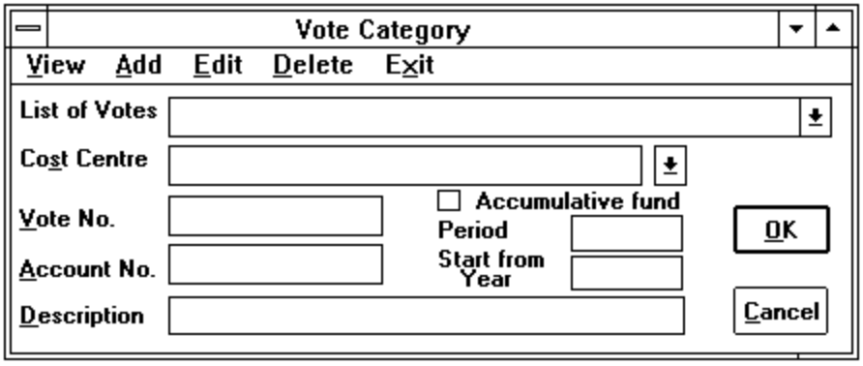

4.4.2 Contents.
1. List of Votes.
Source: Displayed by the system.
Comment: A list of the vote descriptions will be displayed for the users to select.
2. Cost Centre List Box.
Source: Displayed by the system.
Comment: A list of the cost centre descriptions will be displayed for the users to select.
3. Vote No.
Source: Mandatory entry for both 'Add' and 'Edit' commands. Displayed by the system for other commands.
Comment: It is used to display or enter the vote number.
4. Account No.
Source: Displayed by the system.
Comment: It is used to display the account number of the cost centre.
5. Description.
Source: Mandatory entry for both 'Add' and 'Edit' commands. Displayed by the system for other commands.
Comment: It is used to display or enter the vote description.
6. Accumulative fund.
Source: Mandatory entry for both 'Add' and 'Edit' commands. Displayed by the system for other commands.
Comment: It is used to indicate whether the vote is a accumulative fund. Defaulted to non accumulative.
7. Period.
Source: Mandatory entry for both 'Add' and 'Edit' commands. Displayed by the system for other commands. It is only visible when the vote is an accumulative fund.
Comment: It is used to indicate the number of years will be accumulated for the fund. Defaulted to 1.
8. Start from Year.
Source: Mandatory entry for both 'Add' and 'Edit' commands. Displayed by the system for other commands. It is only visible when the vote is an accumulative fund.
Comment: It is used to indicate the first financial year will be started for an accumulative fund. Defaulted to the year of the current system date.
9. OK Button.
As described in Section 4.2.3 item 7.
10. Cancel Button.
As described in Section 4.2.3 item 8.

4.4.3 Controls.
As described in Section 4.2.4.

4.4.4 Error Messages.
1. Please enter the Vote No. !
2. Please select a Cost Centre !
3. Please enter the description !

4.5 Currency Maintenance Dialog Box.

4.5.1 Purpose.
Allows users to create new currencies, view, edit and delete the existing currencies. The currency maintenance dialog box (Figure 4.5.1) is displayed when selecting the 'Currency' command from the Files menu (see Section 4.1.2). A command menu is displayed at the top of the dialog box for the users to select the commands. The command menu is described in Section 4.5.2.
Figure 4.5.1: Currency Maintenance Dialog Box
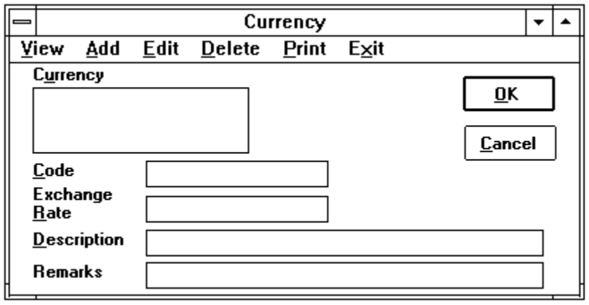

4.5.2 Command Menu.
View | To display the detailed information of the selected record.
Add | To create a new record.
Edit | To edit the selected record.
Delete | To delete the selected record.
Print | To print a list of the exchange rates for all currencies. Refer to Section 5.15.
Exit | To close the dialog box and quits the job.

4.5.3 Contents.
1. Currency List Box.
Source: Displayed by the system.
Comment: All the currencies will be displayed for the user to select.
2. Code.
Source: Mandatory entry for both 'Add' and 'Edit' commands. Displayed by the system for other commands.
Comment: It is used to display or enter the currency code.
3. Exchange Rate.
Source: Mandatory entry for both 'Add' and 'Edit' commands. Displayed by the system for other commands.
Comment: It is used to display or enter the exchange rate.
4. Description.
Source: Mandatory entry for both 'Add' and 'Edit' commands. Displayed by the system for other commands.
Comment: It is used to display or enter the currency description.
5. Remarks.
Source: Mandatory entry for both 'Add' and 'Edit' commands. Displayed by the system for other commands.
Comment: It is used to display or enter the general remarks.
6. OK Button.
As described in Section 4.2.3 item 7.
7. Cancel Button.
As described in Section 4.2.3 item 8.

4.5.4 Controls.
As described in Section 4.2.4.

4.5.5 Error Messages.
1. Please enter the Currency code !
2. Please enter the exchange rate !
3. Please enter the description !

4.6 Professional Society Maintenance Dialog Box.

4.6.1 Purpose.
Allows users to create new professional societies, view, edit and delete the existing professional societies. The professional society maintenance dialog box (Figure 4.6.1) is displayed when selecting the 'Professional Society' command from the Files menu (see Section 4.1.2). A command menu is always displayed at the top of the dialog box for the users to select the commands. For the details of the command menu, please refer to Section 4.2.2.
Figure 4.6.1: Professional Society Maintenance Dialog Box
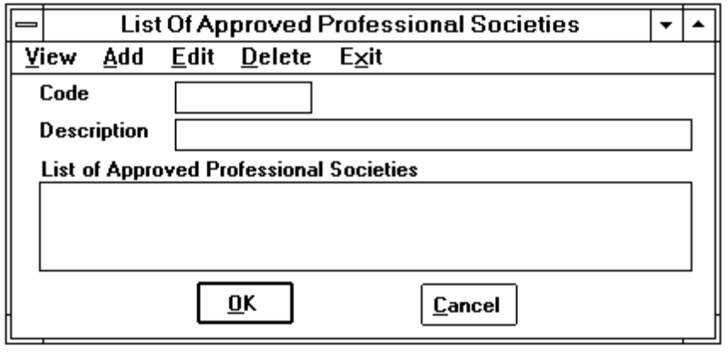

4.6.2 Contents.
1. Code.
Source: Mandatory entry for both 'Add' and 'Edit' commands. Displayed by the system for other commands.
Comment: It is used to display or enter the code of a professional society.
2. Description.
Source: Mandatory entry for both 'Add' and 'Edit' commands. Displayed by the system for other commands.
Comment: It is used to display or enter the name of a professional society.
3. List of Approved Professional Societies.
Source: Mandatory entry for both 'Add' and 'Edit' commands. Displayed by the system for other commands.
Comment: It is used to display or enter the code of a professional society.
4. OK Button.
As described in Section 4.2.3 item 7.
5. Cancel Button.
As described in Section 4.2.3 item 8.

4.6.3 Controls.
As described in Section 4.2.4.

4.6.4 Error Messages.
1. Please enter the Society code !
2. Please enter the description !

4.7 Purchase Orders Dialog Box.

4.7.1 Purpose.
Allows users to create new purchase orders, edit and delete the existing purchase orders. The purchase orders dialog box (Figure 4.7.1) is displayed when selecting the 'Purchase Orders' command from the Purchasing menu (see Section 4.1.2). A command menu is always displayed at the top of the dialog box for the users to select the commands. For the details of the command menu, please refer to Section 4.2.2.
Figure 4.7.1: Purchase Orders Dialog Box
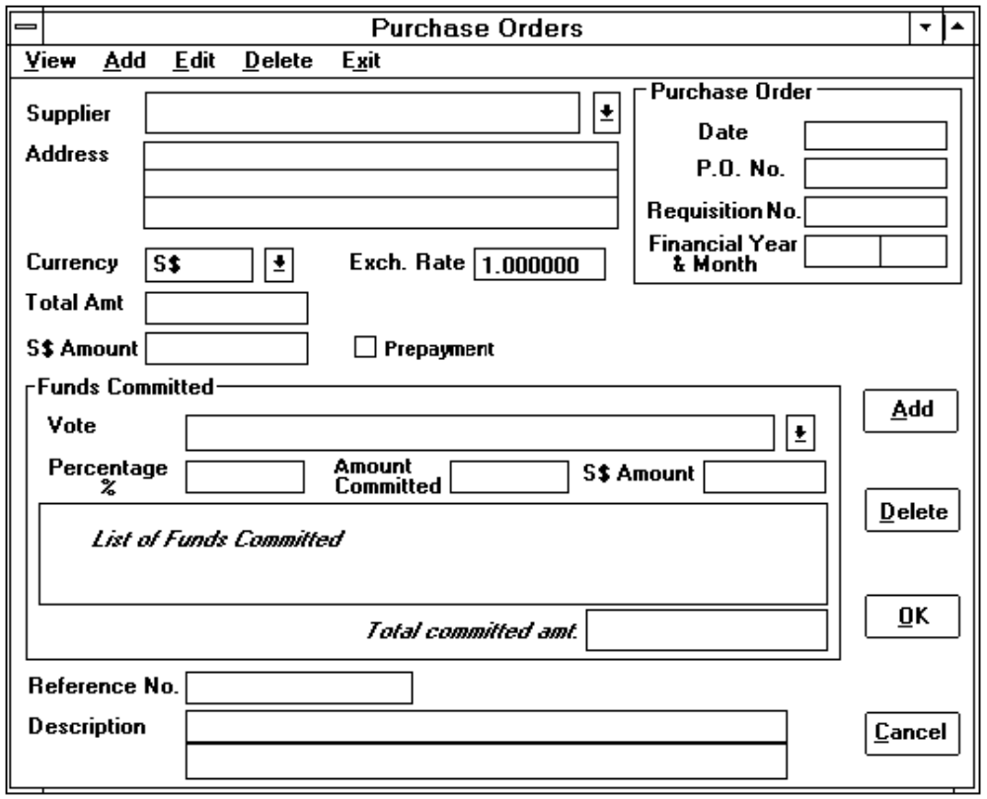

4.7.2 Contents.
1. Date of Purchase Order.
Source: Displayed by the system. It can be overridden when using 'Add' or 'Edit' commands.
Comment: Defaulted to the current system date.
2. P.O. No.
Source: Mandatory entry for both 'Add' and 'Edit' commands. Displayed by the system for other commands.
Comment: It is used to display or enter the purchase order number.
3. Requisition No.
Source: It is an optional entry for both 'Add' and 'Edit' commands. Displayed by the system for other commands.
Comment: It is used to display or enter the requisition number.
4. Financial Year & Month.
Source: Displayed by the system. It can be overridden when using 'Add' or 'Edit' commands.
Comment: Defaulted to the year and month of the accepted date of purchase order.
5. Supplier.
Source: Displayed by the system.
Comment: All the suppliers will be displayed for the users to select.
6. Address.
Source: Displayed by the system.
Comment: It is used to display the address of the selected supplier.
7. Currency.
Source: Displayed by the system.
Comment: All the currencies will be displayed for the users to select. The default value is always 'S$'.
8. Exchange Rate.
Source: Mandatory entry for both 'Add' and 'Edit' commands. Displayed by the system for other commands.
Comment: By default, this value is 1.
9. Total Amount.
Source: Mandatory entry for both 'Add' and 'Edit' commands. Displayed by the system for other commands.
Comment: It is used to display or enter the total amount shown in the purchase order.
10. S$ Amount.
Source: System generated and displayed. It can be overridden when using 'Add' or 'Edit' commands.
Comment: This is the S$ equivalent amount of the Total Amount (see item 9).
S$ Amount = Total Amount * Exchange Rate
11. Prepayment.
Source: Mandatory entry for both 'Add' and 'Edit' commands. Displayed by the system for other commands.
Comment: It is used to indicate whether the purchase order has to be paid upon issuing the order. Defaulted to no prepayment.
12. Cheque No.
Source: Mandatory entry for both 'Add' and 'Edit' commands. Displayed by the system for other commands.
Comment: It is used to display or enter the cheque number. This item will be displayed only when the Prepayment (see item 11) check box is marked (a 'X' is shown in the small box).
13. Vote.
Source: Displayed by the system.
Comment: All the vote categories will be displayed for the users to select.
14. Percentage %.
Source: Mandatory entry for both 'Add' and 'Edit' commands. Displayed by the system for other commands.
Comment: It is used to display or enter the percentage of the total amount (see item 9) to be committed for a selected vote. Defaulted to 100%.
15. Amount Committed.
Source: System generated and displayed. It can be overridden when using 'Add' or 'Edit' commands.
Comment: This is the fund committed amount for the selected vote.
Amount committed = Total Amount(item 9) * Percentage %(item14)
16. S$ Amount in the Funds Committed group box.
Source: System generated and displayed. It can be overridden when using 'Add' or 'Edit' commands.
Comment: This is the S$ equivalent amount of the Committed Amount (see item 15).
S$ Amount = Amount Committed * Exchange Rate
17. List of Funds Committed in the Funds Committed group box.
Source: System generated and displayed.
Comment: It is used to display a list of funds committed. It contains the vote description followed by the committed amount and the S$ equivalent committed amount.
18. Total Committed Amt. in the Funds Committed group box.
Source: Generated and displayed by the system.
Comment: This is the total amount of the funds committed.
19. Reference No.
Source: Mandatory entry for both 'Add' and 'Edit' commands. Displayed by the system for other commands.
Comment: This is the document reference number for filing purpose. Defaulted to purchase order number.
20. Description.
Source: Mandatory entry for both 'Add' and 'Edit' commands. Displayed by the system for other commands.
Comment: It is used to display or enter the detailed information of the purchase order. Two lines with 40 characters is provided.
21. Add Button.
Source: It is an optional push button when using the command 'Add' or 'Edit'.
Comment: This button will be visible when the users select a vote from the Vote list box (see item 13). If this button is pressed, then the selected vote account and the accepted amount committed (see item 15) will be added into the List of Funds Committed list box (see item 17). In addition to this, the accepted amount committed (see item 15) is also accumulated and displayed in the total committed amount text box (see item 18).
22. Delete Button.
Source: It is an optional push button when using the command 'Add' or 'Edit'.
Comment: This button is pressed when the users select an item from the List of Funds Committed list box (see item 17). The selected item will be removed and the committed amount will be subtracted from the total committed amount (see item 18) when this button is pressed.
23. OK Button.
As described in Section 4.2.3 item 7.
24. Cancel Button.
As described in Section 4.2.3 item 8.

4.7.3 Controls.
1. All the settled purchase order records are not allowed to be amended or deleted.
2. When deleting a purchase order record, a dialog box (Figure 4.2.2) is displayed for the user to confirm whether the selected record should be deleted.

4.7.4 Error Messages.
1. This record already exists.
2. Please enter the PO. No. !
3. Please enter the Reference No. !
4. Please select a Supplier !
5. Please enter the Requisition No. !
6. Please select a currency code !
7. Please enter the Funds committed !
8. The exchange rate should be greater than 0 !
9. Please enter the total amount !
10. The S$ amount is incorrect. Please enter again !!!!
11. The total committed amount is not equal to the entered committed amount !
12. The date format should be 'dd/mm/yy' !
13. The month should be between 1 and 12 !
14. There is only nn days in that month !
(nn is the number of days of the month.)
15. Please enter the date again !

4.8 Delivery Orders Dialog Box.

4.8.1 Purpose.
Allows users to create new delivery orders, edit and delete the existing delivery orders. Two types of delivery orders dialog boxes (Figures 4.8.2 and 4.8.3) are provided for entering the delivery order for the two possible cases: with POs and without POs. A popup menu (Figure 4.8.1) is displayed when selecting the 'Delivery Orders' command from the Purchasing menu (see Section 4.1.2). A command menu is always displayed at the top of the dialog box for the users to select the commands. For the details of the command menu, please refer to Section 4.2.2.
Figure 4.8.1: Delivery Orders Popup menu
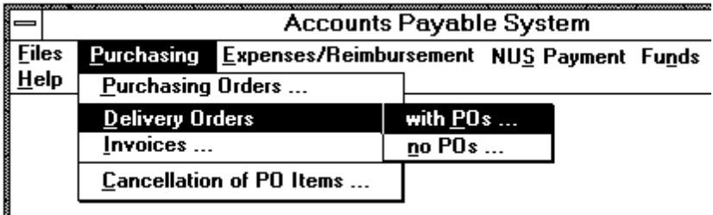

4.8.2 Contents.
1. P.O. No.
Source: Displayed by the system.
Comment: This is the PO number of the selected purchase order.
Figure 4.8.2: Dialog Box for Delivery Order with POs
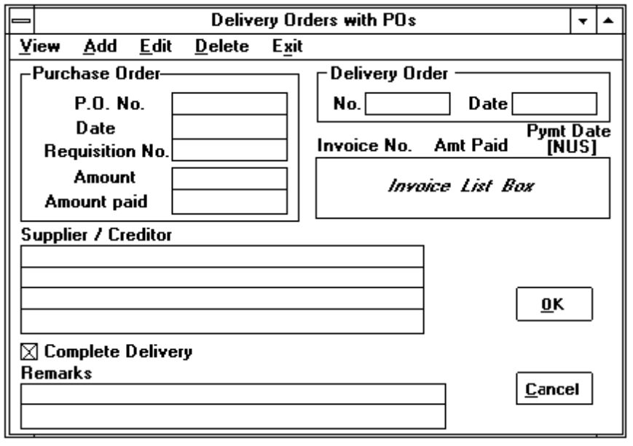
Figure 4.8.3: Dialog Box for Delivery Orders without POs
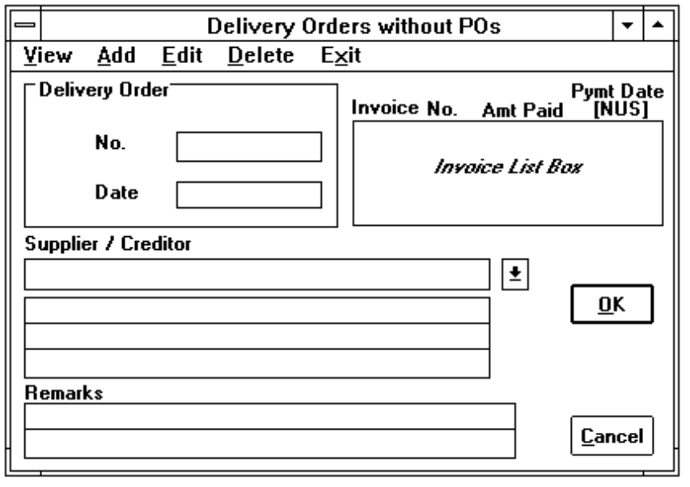
2. Date in the Purchase Order group box.
Source: Displayed by the system.
Comment: This is the PO date of the selected purchase order.
3. Requisition No.
Source: Displayed by the system.
Comment: This is the requisition number of the selected purchase order.
4. Amount in the Purchase Order group box.
Source: Displayed by the system.
Comment: This is the total PO amount of the selected purchase order.
5. Amount Paid in the Purchase Order group box.
Source: Displayed by the system.
Comment: This is the total amount paid of the selected purchase order.
6. Delivery Order No.
Source: Mandatory entry for 'Add' command. Displayed by the system for other commands.
Comment: It is used to display or enter the delivery order number.
7. Delivery Order Date.
Source: Mandatory entry for both 'Add' and 'Edit' commands. Displayed by the system for other commands.
Comment: Defaulted to the current system date. It is used to display or enter the delivery order date.
8. Invoice No. in the Invoice list box.
Source: Displayed by the system.
Comment: It is used to display the Invoice No. of the invoice received for the delivery order when using 'View', 'Edit' or 'Delete' command.
9. Amount Paid in the Invoice list box.
Source: Displayed by the system.
Comment: It is used to display the amount paid of the invoice when using 'View', 'Edit' or 'Delete' command.
10. Payment date (NUS) in the Invoice list box.
Source: Displayed by the system.
Comment: It is used to display the actual NUS payment date of the invoice when using 'View', 'Edit' or 'Delete' command.
11. Supplier / Creditor.
Source: Mandatory entry for both 'Add' and 'Edit' commands in the dialog box for delivery orders without POs (Figure 4.8.3).Displayed by the system for other functions.
Comment: All the suppliers will be displayed for the users to select if it is a mandatory entry. The address of the specified supplier is displayed below the supplier's name.
12. Complete Delivery check box.
Source: Mandatory entry for both 'Add' and 'Edit' commands. Displayed by the system for other commands. It is only visible in the delivery order with POs dialog box (Figure 4.8.2).
Comment: It is used to indicate whether the goods has been delivered completely by the supplier. Defaulted to Complete Delivery.
13. Remarks.
Source: Mandatory entry for both 'Add' and 'Edit' commands. Displayed by the system for other commands.
Comment: It is used to display or enter the general purpose description. There are two lines with 40 characters each provided.
14. OK Button.
As described in Section 4.2.3 item 7.
15. Cancel Button.
As described in Section 4.2.3 item 8.

4.8.3 Controls.
1. All the settled delivery orders are not allowed to be amended or deleted.
2. When deleting a delivery order record, a dialog box (Figure 4.2.2) is displayed for the user to confirm whether the selected record should be deleted.

4.8.4 Error Messages.
1. This record already exists.
2. Please select a Supplier !
3. The date format should be 'dd/mm/yy' !
4. The month should be between 1 and 12 !
(nn is the number of days of the month.)
5. Please enter the date again !

4.9 Invoices Dialog Box.

4.9.1 Purpose.
Allows users to record a new invoice received from a supplier/creditor, and also edit and delete the existing invoice records. Two types of dialog box (Figures 4.9.2 and 4.9.3) are provided for entering invoice for both the possible cases: with DOs and without DOs. A popup menu (Figure 4.9.1) is displayed when selecting the 'Invoice' command from the Purchasing menu (see Section 4.1.2). A command menu is always displayed at the top of the dialog box for the users to select the commands. For the details of the command menu, please refer to Section 4.2.2.
Figure 4.9.1: Invoices Popup menu
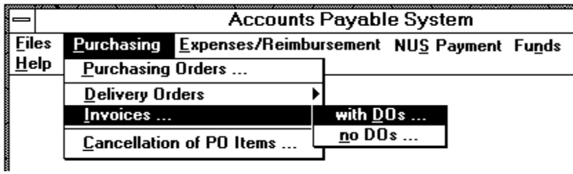
Figure 4.9.2: Dialog Box for Invoice received from Supplier with DOs
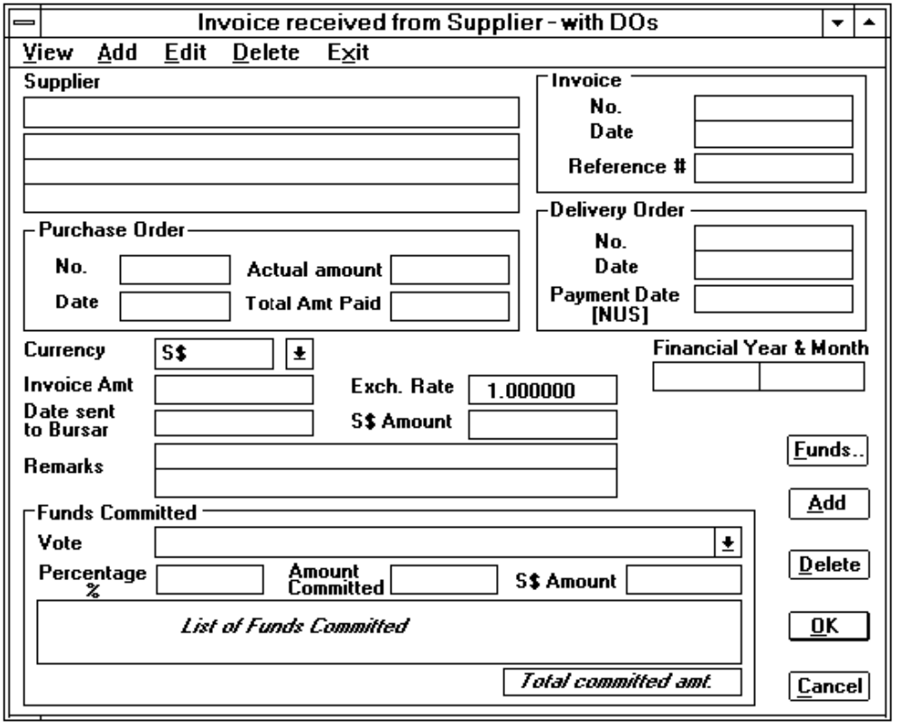
Figure 4.9.3: Dialog Box for Invoice received from Supplier/Creditor without DOs
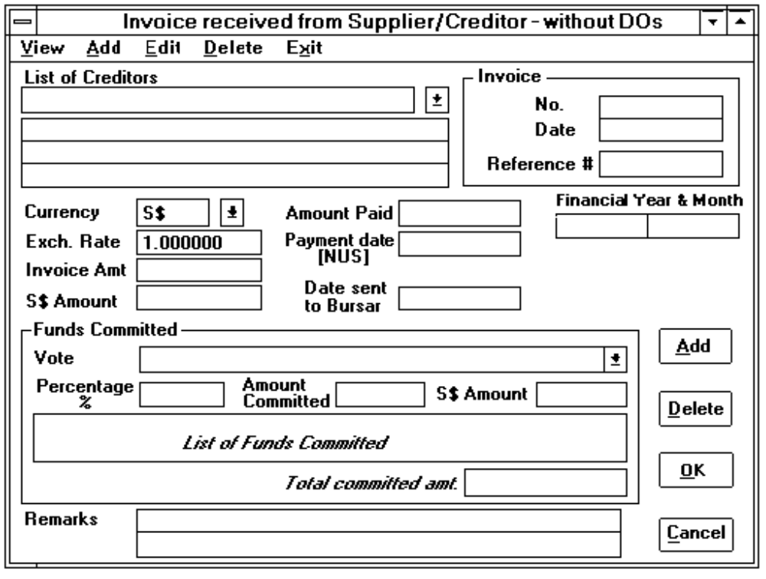

4.9.2 Contents.
1. Invoice No.
Source: Mandatory entry for 'Add' command. Displayed by the system for other commands.
Comment: It is used to display or enter the invoice number.
2. Invoice Date.
Source: Mandatory entry for both 'Add' and 'Edit' commands. Displayed by the system for other commands.
Comment: Defaulted to the current system date. It is used to display or enter the invoice date.
3. Reference #.
Source: Mandatory entry for both 'Add' and 'Edit' commands in the dialog box for invoices received from supplier/creditor without DOs. (Figure 4.9.3).
Comment: It is used to display or enter the reference number for filing purpose.
4. Supplier / Creditor.
Source: Mandatory entry for both 'Add' and 'Edit' commands in the dialog box for invoice received from supplier/creditor without DOs (Figure 4.9.3). Displayed by the system for other functions.
Comment: All the suppliers/creditors will be displayed for the users to select if it is a mandatory entry. The address of the specified supplier is displayed below the supplier's/ creditor's name.
5. P.O. No.
Source: Displayed by the system.
Comment: This is the PO number of the selected purchase order.
6. Date in the Purchase Order group box.
Source: Displayed by the system.
Comment: This is the PO date of the selected purchase order.
7. Actual mount in the Purchase Order group box.
Source: Displayed by the system.
Comment: This is the total PO amount of the selected purchase order.
8. Total Amount Paid in the Purchase Order group box.
Source: Displayed by the system.
Comment: This is the total amount paid of the selected purchase order.
9. Delivery Order No.
Source: Displayed by the system for other commands.
Comment: It is used to display the delivery order number.
10. Delivery Order Date.
Source: Displayed by the system.
Comment: It is used to display the delivery order date.
11. Amount Paid shown in Figure 4.9.3.
Source: Displayed by the system.
Comment: It is used to display the amount paid of the invoice when using 'View', 'Edit' or 'Delete' command.
12. Payment date (NUS).
Source: Displayed by the system.
Comment: It is used to display the actual NUS payment date of the delivery order when using 'View', 'Edit' or 'Delete' command.
13. Financial Year & Month.
Source: Displayed by the system. It can be overridden when using 'Add' or 'Edit' commands in the dialog box of invoice received from supplier/creditor without DOs (Figure 4.9.3).
Comment: Defaulted to the year and month of the accepted invoice date.
14. Currency.
Source: Mandatory entry for both 'Add' and 'Edit' commands in the dialog box for invoice received from supplier/creditor without DOs menu command (Figure 4.9.3). Displayed by the system for other functions.
Comment: All the currencies will be displayed for the users to select. The default value is always 'S$'.
15. Exchange Rate.
Source: Mandatory entry for both 'Add' and 'Edit' commands in the dialog box for invoice received from supplier/creditor without DOs menu command (Figure 4.9.3). Displayed by the system for other functions.
Comment: By default, this value is 1.
16. Invoice Amt.
Source: Mandatory entry for both 'Add' and 'Edit' commands. Displayed by the system for other commands.
Comment: It is used to display or enter the invoice amount.
17. S$ Amount.
Source: System generated and displayed. It can be overridden when using 'Add' or 'Edit' commands.
Comment: This is the S$ equivalent amount of the Invoice Amt. (see item 16).
S$ Amount = Invoice Amt. * Exchange Rate
18. Date sent to Bursar.
Source: Mandatory entry for both 'Add' and 'Edit' commands. Displayed by the system for other commands.
Comment: It is used to indicate the date of sending the received invoice to the NUS Bursar's Office. Defaulted to the current system date.
19. Vote.
As described in Section 4.7.2 item 13.
20. Percentage %.
As described in Section 4.7.2 item 14.
21. Amount Committed.
As described in Section 4.7.2 item 15.
22. S$ Amount in the Funds Committed group box.
As described in Section 4.7.2 item 16.
23. List of Funds Committed in the Funds Committed group box.
As described in Section 4.7.2 item 17.
24. Total Committed Amt. in the Funds Committed group box.
As described in Section 4.7.2 item 18.
25. Remarks.
Source: Mandatory entry for both 'Add' and 'Edit' commands. Displayed by the system for other commands.
Comment: It is used to display or enter the general purpose description. There are two lines with 40 characters each provided.
26. Funds Button.
Source: Optional push button. It is only visible for invoice received with DOs.
Comment: When this button is pressed, another Committed Funds dialog box (Figure 4.9.4) will be displayed for the users to enter the actual amount of the committed funds to be paid for that invoice. This feature caters for the partially delivery of the item on the purchase order. For the detailed information about the committed funds dialog box, please refer to Section 4.9.3.
27. Add Button.
As described in Section 4.7.2 item 21.
28. Delete Button.
As described in Section 4.7.2 item 22.
29. OK Button.
As described in Section 4.2.3 item 7.
30. Cancel Button.
As described in Section 4.2.3 item 8.

4.9.3 Committed Funds Dialog Box.
The dialog box shown in Figure 4.9.4 is displayed for the user to enter the actual amount of committed funds to be paid for the invoice when the user presses the Funds button (see Section 4.9.2 item 25).
Figure 4.9.4: Funds to be committed for the received invoice
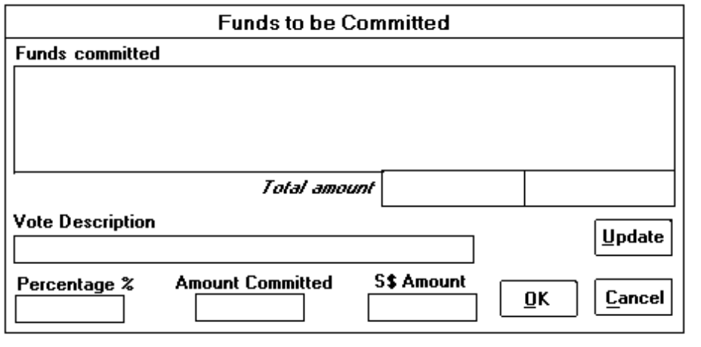
1. Funds committed.
Source: Displayed by the system.
Comment: The system will, based on the invoice amount and the original proportion of the committed amount of each vote, generate a new list of the funds to be paid for the invoice. It contains the vote description followed by the committed amount and the S$ equivalent committed amount.
2. Total amount.
Source: Displayed by the system.
Comment: It is used to display the total committed amount and S$ equivalent committed amount shown in the list box (see item 1). Please note that these two amounts should be equal to the invoice amount and the S$ equivalent invoice amount respectively.
3. Vote description.
Source: Displayed by the system. It is only visible when using 'Add' and 'Edit' commands.
Comment: It is used to display the vote description of the selected item in the list box of Funds committed (see item 1).
4. Percentage %.
Source: Displayed by the system.
Comment: It is used to compute the amount committed (see item 5) of a selected vote.
5. Amount Committed.
Source: Generated and displayed by the system. It can be overridden if there is a difference between the actual amount and the generated amount.
Comment: It is used to display or enter the committed amount of the selected item in the list box of Funds committed (see item 1).
Amount Committed = Invoice Amount (refer to item 16 in Section 4.9.2) * Percentage %
6. S$ Amount.
Source: Generated and displayed by the system. It can be overridden if there is a difference between the actual amount and the generated amount.
Comment: It is used to display or enter the S$ equivalent committed amount of the selected item in the list box of Funds committed (see item 1).
7. Update Button.
Source: Optional push button. It is only visible when using 'Add' and 'Edit' commands.
Comment: When this button is pressed, the committed amount and the S$ equivalent amount of the selected vote (see item 3, 4 and 5) will be updated and displayed in the list box of Funds committed (see item 1).
8. OK Button.
Source: It is used to confirm all the entries are correct.
Comment: The dialog box will be closed and return back to the previous dialog box when this button is pressed.
9. Cancel Button.
Source: Optional push button. It is used to cancel the job.
Comment: When this button is pressed, all the amended entries will be remain unchanged.

4.9.4 Controls.
1. All the settled invoice are not allowed to be amended or deleted.
2. When deleting an invoice record, a dialog box (Figure 4.2.2) is always displayed for the user to confirm whether the selected record should be deleted.
3. All the settled purchase orders/delivery orders will not be displayed again in the common dialog box (see Section 4.20) for users to update the detailed invoice information.

4.9.5 Error Messages.
1. This record already exists.
2. Please enter the Reference No. !
3. Please select a Supplier !
4. Please select a currency code !
5. Please enter the Funds committed !
6. The exchange rate should be greater than 0 !
7. Please enter the invoice amount and the S$ amount !
8. The S$ amount is incorrect. Please enter again !!!!
9. The total committed amount is not equal to the entered committed amount !
10. The date format should be 'dd/mm/yy' !
11. The month should be between 1 and 12 !
12. There is only nn days in that month !
(nn is the number of days of the month.)
13. Please enter the date again !

4.10 Credit / Debit Notes Dialog Boxes.

4.10.1 Purpose.
Allows users to create new credit /debit notes, edit and delete the existing credit / debit notes. The credit notes and debit notes dialog box (Figure 4.10.1 & 4.10.2) will be displayed when selecting the 'Credit Notes' and 'Debit Notes' command from the Purchasing menu (see Section 4.1.2) respectively. A command menu is always displayed at the top of the dialog box for the users to select the commands. For the details of the command menu, please refer to Section 4.2.2.

4.10.2 Contents.
1. List of Invoices.
Source: Displayed by the system for users to select a record to display or update.
Comment: It is used to display all the invoices or credit/debit notes for the users to select. All records contain supplier's name followed by the Invoice number and the credit/debit notes number.
2. Credit / Debit Notes No.
Source: Mandatory entry for both 'Add' and 'Edit' command. Displayed by the system for other commands.
Comment: It is used to display or enter the credit/debit notes number.
3. Credit / Debit Notes Date.
Source: Mandatory entry for both 'Add' and 'Edit' command. Displayed by the system for other commands.
Comment: It is used to display or enter the date of credit/debit notes.
4. Invoice No.
Source: Displayed by the system.
Comment: It is used to display the invoice number.
5. Invoice Date.
Source: Displayed by the system.
Comment: It is used to display the date of invoice.
Figure 4.10.1: Credit Notes Dialog Box
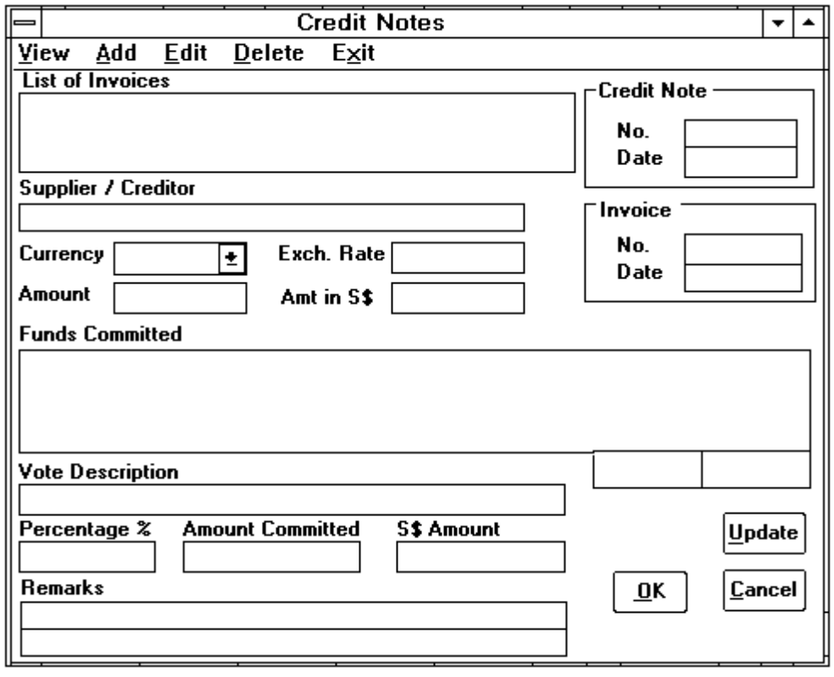
Figure 4.10.2: Debit Notes Dialog Box
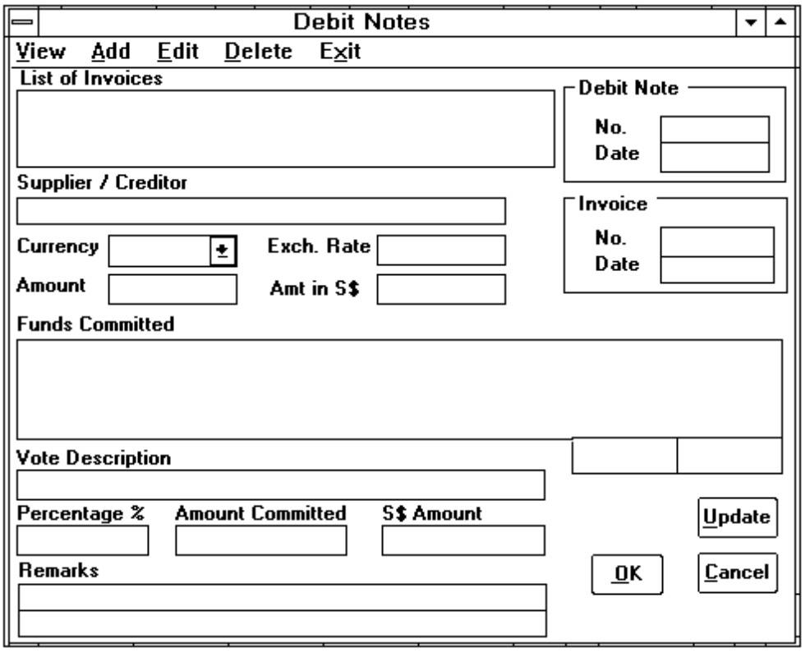
6. Supplier/Creditor.
Source: Displayed by the system.
Comment: It is used to display the name of supplier/creditor.
7. Currency.
As described in Section 4.7.2 item 7. By default, it is the original currency of the selected invoice.
8. Exchange Rate.
As described in Section 4.7.2 item 8. By default, it is the original exchange rate of the selected invoice.
9. Amount.
Source: Mandatory entry for both 'Add' and 'Edit' command. Displayed by the system for other commands.
Comment: It is used to display or enter the amount to be credited/debited.
10. Amount in S$.
Source: System generated and displayed. It can be overridden if there is any difference between the actual amount and the generated amount.
Comment: It is used to display or enter the S$ equivalent credited/debited amount.
11. Fund Committed.
Source: Display by the system.
Comment: The system will, based on the entered amount (item 9) and the original proportion of the committed amount of each vote, generate a new list of the funds to be adjusted. It contains the vote description followed by the adjusted amount and the S$ equivalent amount.
12. Vote description.
As described in Section 4.9.3 item 3.
13. Percentage %.
As described in Section 4.9.3 item 4.
14. Amount Committed.
As described in Section 4.9.3 item 5.
15. S$ Amount.
As described in Section 4.9.2 item 25.
16. Remarks.
As described in Section 4.9.3 item 6.
17. Update Button.
As described in Section 4.9.3 item 7.
18. OK Button.
As described in Section 4.2.3 item 7.
19. Cancel Button.
As described in Section 4.2.3 item 8.

4.10.3 Controls.
1. When deleting credit/debit note record, a dialog box (Figure 4.2.2) is always displayed for the user to confirm whether the selected record should be deleted.

4.10.4 Error Messages.
1. This record already exists.
2. Please enter the Credit / Debit Notes No. !
3. The exchange rate should be greater than 0 !
4. Please enter the amount and the S$ amount to be credited/debited !
5. The S$ amount is incorrect. Please enter again !!!!
6. The total committed amount is not equal to the credited/debited amount !
7. The date format should be 'dd/mm/yy' !
8. The month should be between 1 and 12 !
9. There is only nn days in that month !
(nn is the number of days of the month.)
10. Please enter the date again !

4.11 Cancellation of PO Items Dialog Box.

4.11.1 Purpose.
Allows users to cancel some of the purchase items from a purchase order when the purchase items are unable to be delivered by the supplier. A dialog box (Figure 4.11.1) is displayed when selecting the 'Cancellation of PO items' command from the Purchasing menu (see Section 4.1.2). A command menu is always displayed at the top of the dialog box for the users to select the commands. For the details of the command menu, please refer to Section 4.2.2.
Figure 4.11.1: Cancellation of PO Items Dialog Box.
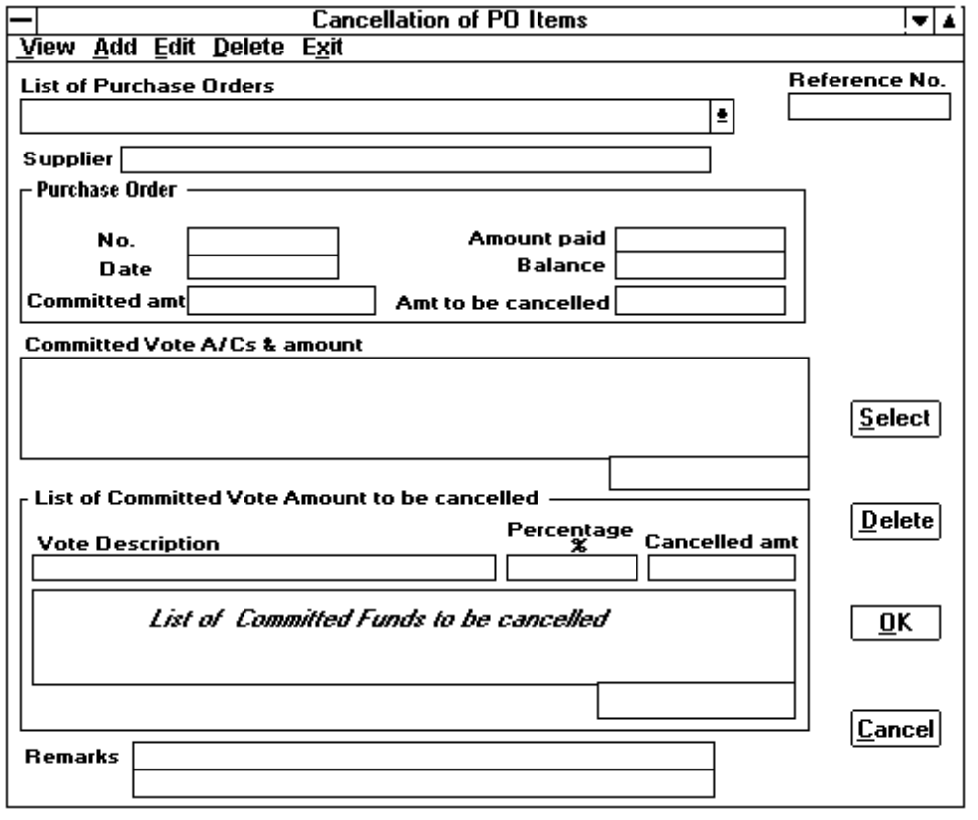

4.11.2 Contents.
1. List of Purchase Orders.
Source: Displayed by the system.
Comment: All the purchase orders will be displayed for user to select when using 'Add' commands. Otherwise, a list of all cancelled purchase orders will be displayed when using other commands. The purchase order record consists of PO number, PO date and the supplier's name. For the cancelled purchase order record, it contains PO number followed by reference number, cancellation date and the supplier's name.
2. Reference No.
Source: Generated and displayed by the system.
Comment: This reference number is generated by the system when using 'Add' command. The number is prefixed by 'CL-' Eg. CL-999999.
3. Supplier.
Source: Displayed by the system.
Comment: It is used to display the supplier's name of the selected PO.
4. P.O. No in the Purchase Order group box.
Source: Displayed by the system.
Comment: This is the PO number of the selected purchase order.
5. Date in the Purchase Order group box.
Source: Displayed by the system.
Comment: This is the PO date of the selected purchase order.
6. Committed amount in the Purchase Order group box.
Source: Displayed by the system.
Comment: This is the total PO amount of the selected purchase order.
7. Amount Paid in the Purchase Order group box.
Source: Displayed by the system.
Comment: This is the total amount paid of the selected purchase order.
8. Balance in the Purchase Order group box.
Source: Displayed by the system.
Comment: This is the unpaid amount of the selected purchase order.
9. Amt to be cancelled in the Purchase Order group box.
Source: Mandatory entry for both 'Add' and 'Edit' commands. Displayed by the system for other commands.
Comment: This is the total amount to be cancelled for the selected purchase order.
10. Committed Vote A/Cs & Amount.
Source: Displayed by the system.
Comment: It is used to display all the committed funds of the selected purchase order. It contains the vote description and committed amount and the total committed amount is displayed under this box.
11. Vote description.
Source: Displayed by the system.
Comment: It is used to display the vote description of the selected item in the list box of Committed Vote A/Cs & Amount (see item 10).
12. :Percentage %.
Source: Displayed by the system.
Comment: It is used to compute the cancelled amount (see item 13) of the selected vote.
13. Cancelled Amount.
Source: Generated and displayed by the system. It can be overridden if there is a difference between the actual amount and the generated amount.
Comment: It is used to display or enter the amount to be cancelled for the specified vote.
Cancelled Amount = Amt to be cancelled (item 9) * Percentage %
14. List of Committed Funds to be Cancelled.
Source: Displayed by the system.
Comment: It is used to display all the committed funds of the selected purchase order. It contains the vote description and cancelled amount and the total cancelled amount is displayed under this box.
15. Remarks.
Source: Mandatory entry for both 'Add' and 'Edit' commands. Displayed by the system for other commands.
Comment: It is used to display or enter the general purpose description for the cancelled PO items. There are two lines with 40 characters each provided.
16. Select Button.
Source: Optional push button. It is only visible when using 'Add' and 'Edit' commands and the user clicks on a item in the list box of Committed Vote A/Cs & Amount (see item 10).
Comment: The vote description and the accepted cancelled amount will be shown in the list box of Committed Funds to be Cancelled when this button is pressed (see item 11).
17. Delete Button.
Source: It is an optional push button when using the command 'Add' or 'Edit'.
Comment: This button is pressed when the users select an item from the List of Committed Funds to be Cancelled list box (see item 14). The selected item will be removed and the cancelled amount will be subtracted from the total cancelled amount when this button is pressed.
18. OK Button.
As described in Section 4.2.3 item 7.
19. Cancel Button.
As described in Section 4.2.3 item 8.

4.11.3 Controls.
1. All the settled purchase orders are not allowed to be cancelled.
2. When deleting a record, a dialog box (Figure 4.2.2) is always displayed for the user to confirm whether the selected record should be deleted.

4.11.4 Error Messages.
1. Please enter the cancelled amount !
2. The total cancelled amount is not equal to the entered cancelled amount !

4.12 Claims/Payments Dialog Box.

4.12.1 Purpose.
Allows users to create new claim/payment records, edit and delete the existing claim/payment records. Three types of dialog box (Figures 4.12.2, 4.12.3 and 4.12.4) are provided for entering claims and expense payments. A popup menu (Figure 4.12.1) is displayed when selecting the 'Claims' command from the Expenses/Reimbursement menu (see Section 4.1.2). A command menu is always displayed at the top of the dialog box for the users to select the commands. For the details of the command menu, please refer to Section 4.2.2.
Figure 4.12.1: Expenses/Reimbursement Popup menu
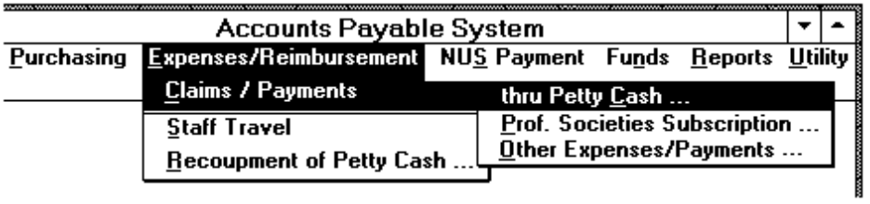

4.12.2 Contents.
The contents of each dialog box will be described in the following sections.

4.12.2.1 Claims/Payments thru Petty Cash.
The dialog box shown in Figure 4.12.2 is used for entering claims/payments thru petty cash.
Figure 4.12.2: Dialog Box for Claims/Payments thru Petty Cash
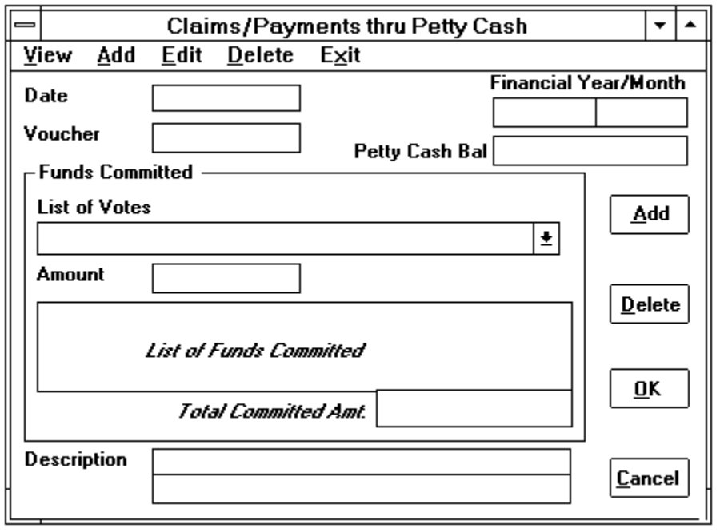
1. Date.
Source: Mandatory entry for both 'Add' and 'Edit' commands. Displayed by the system for other commands.
Comment: Defaulted to the current system date.
2. Voucher.
Source: Mandatory entry for both 'Add' and 'Edit' commands. Displayed by the system for other commands.
Comment: It is used to display or enter the voucher number.
3. Financial Year & Month.
Source: Displayed by the system. It can be overridden when using 'Add' or 'Edit' commands.
Comment: Defaulted to the year and month of the accepted date (item 1).
4. List of Votes.
As described in Section 4.7.2 item 13.
5. Amount.
Source: Mandatory entry for both 'Add' and 'Edit' commands. Displayed by the system for other commands.
Comment: It is used to display or enter the amount claimed. For the detailed information please refer to item 15 in Section 4.7.2.
6. List of Funds Committed in the Funds Committed group box.
As described in Section 4.7.2 item 17.
7. Total Committed Amt. in the Funds Committed group box.
As described in Section 4.7.2 item 18.
8. Description.
Source: Mandatory entry for both 'Add' and 'Edit' commands. Displayed by the system for other commands.
Comment: It is used to display or enter the general purpose description. Two lines with 40 characters each are provided.
9. Add Button.
As described in Section 4.7.2 item 21.
10. Delete Button.
As described in Section 4.7.2 item 22.
11. OK Button.
As described in Section 4.2.3 item 7.
12. Cancel Button.
As described in Section 4.2.3 item 8.

4.12.2.2 Professional Societies Subscription.
The following dialog box (Figure 4.12.3) is used to enter the claims for subscription to professional societies. There is a common commands menu displayed at the top of the dialog box for the users to select the commands. The 'Print' command is used to print the claims request letter that is sent to the NUS Bursar's Office. For the details of the other menu commands, please refer to Section 4.2.2.
1. Reference No.
Source: Generated and displayed by the system.
Comment: The reference number is generated once the entry is confirmed to be accepted. It is prefixed by 'PF-' Eg. PF-999999.
Figure 4.12.3: Claims for Subscription to Professional Societies Dialog Box
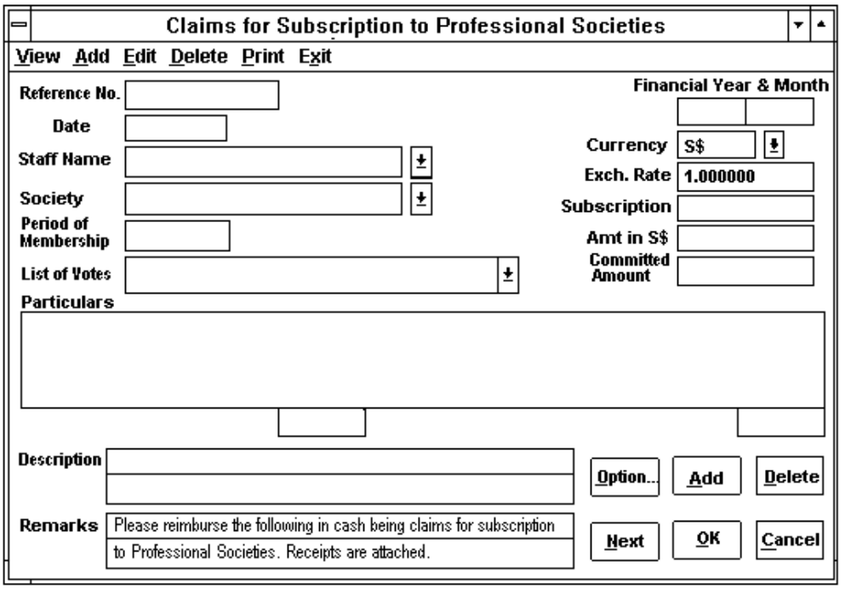
2. Date.
Source: Mandatory entry for both 'Add' and 'Edit' commands. Displayed by the system for other commands.
Comment: Defaulted to the current system date.
3. Staff Name.
Source: Mandatory entry for both 'Add' and 'Edit' commands. Displayed by the system for other commands.
Comment: A list of staff name that have been created will be displayed for the users to select. It also allows user to enter a staff name that does not exist in the list and this new staff record will be created once the entry is confirmed to be updated (refer to item 17 for detailed information).
4. Society.
Source: Mandatory entry for both 'Add' and 'Edit' commands. Displayed by the system for other commands.
Comment: A list of approved professional societies is displayed for user to select.
5. Period of Membership.
Source: Mandatory entry for both 'Add' and 'Edit' commands. Displayed by the system for other commands.
Comment: Defaulted to the current year Eg. 1993.
6. Financial Year & Month.
As described in Section 4.12.2.1 item 3.
7. Currency.
As described in Section 4.7.2 item 7.
8. Exchange Rate.
As described in Section 4.7.2 item 8.
9. Subscription.
Source: Mandatory entry for both 'Add' and 'Edit' commands. Displayed by the system for other commands.
Comment: It is used to display and enter the amount of subscription to be claimed.
10. Amt. in S$.
Source: System generated and displayed.
Comment: This is the actual S$ amount that can be claimed. It is computed by the system and the maximum amount is S$ 125. The system will ensure that a staff member cannot claim more than S$ 125 per financial year.
11. List of Votes.
As described in Section 4.7.2 item 13.
12. Committed Amount.
As described in Section 4.7.2 item 15.
13. Particulars list box.
Source: System generated and displayed.
Comment: It is used to display a list of subscription claims and funds committed. It contains the staff name followed by subscription amount, vote description, and committed amount.
14. Total Committed Amt. in the Funds Committed group box.
As described in Section 4.7.2 item 18.
15. Description.
As described in Section 4.12.2.1 item 8.
16. Remarks.
Source: Displayed by the system. It can be overridden when using 'Add' and 'Edit' commands.
Comment: This is the claims instruction to be printed on the claims letter that is sent to the NUS Bursar's Office. There are two lines with 70 characters each provided.
17. Option Button.
Source: Optional push button.
Comment: An authorised user can create new staff records or edit the existing staff records by pressing this button. When it is pressed, the staff information dialog box (Figure 4.19.1) will be displayed. For the detailed information, please refer to Section 4.19.
18. Add Button.
As described in Section 4.7.2 item 21.
19. Delete Button.
As described in Section 4.7.2 item 22.
20. Next Button.
Source: Optional push button.
Comment: It is used to reset the total committed amount of a staff member's claims.
21. OK Button.
As described in Section 4.2.3 item 7.
22. Cancel Button.
As described in Section 4.2.3 item 8.

4.12.2.3 Other Expenses/Payments.
The dialog box shown in Figure 4.12.4 is used to enter other expenses claimed.
1. Reference No.
As described in Section 4.12.2.2 item 1.
2. Date.
As described in Section 4.12.2.2 item 2.
3. Financial Year & Month.
As described in Section 4.12.2.1 item 3.
4. Currency.
As described in Section 4.7.2 item 7.
5. Exchange Rate.
As described in Section 4.7.2 item 8.
Figure 4.12.4: Dialog Box for Other Expenses/Payments
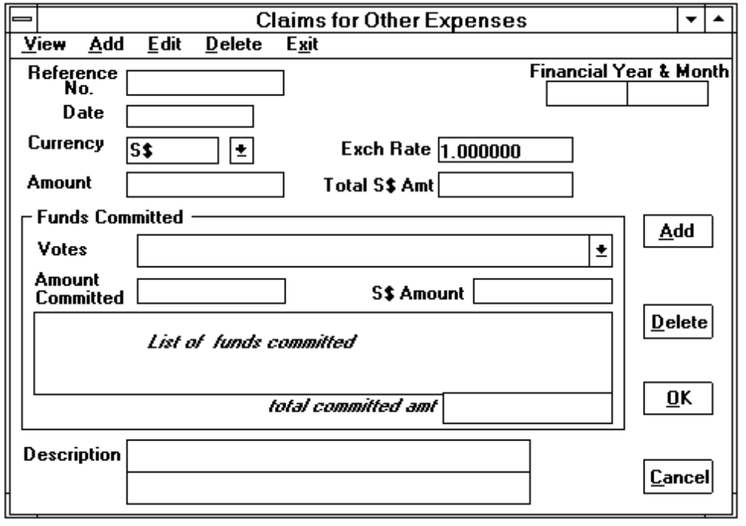
6. Amount.
Source: Mandatory entry for both 'Add' and 'Edit' commands. Displayed by the system for other commands.
Comment: It is used to display or enter the amount claimed. For detailed information please refer to item 14 in Section 4.7.2.
7. Total S$ Amt.
Source: System generated and displayed. It can be overridden when using 'Add' or 'Edit' commands.
Comment: This is the S$ equivalent amount of the Amount (see item 6).
Total S$ Amount = Amount * Exchange Rate
8. List of Votes.
As described in Section 4.7.2 item 13.
9. Committed Amount in the Funds Committed group box.
As described in Section 4.7.2 item 14.
10. S$ Amount in the Funds Committed group box.
As described in Section 4.7.2 item 15.
11. Total Committed Amt. in the Funds Committed group box.
As described in Section 4.7.2 item 17.
12. Description.
As described in Section 4.12.2.1 item 8.
13. Add Button.
As described in Section 4.7.2 item 20.
14. Delete Button.
As described in Section 4.7.2 item 21.
15. OK Button.
As described in Section 4.2.3 item 7.
16. Cancel Button.
As described in Section 4.2.3 item 8.

4.12.3 Controls.
1. All the settled claims/expense payment records are not allowed to be amended or deleted.
2. When deleting a record, a dialog box (Figure 4.2.2) is always displayed for the user to confirm whether the selected record should be deleted.

4.12.4 Error Messages.
1. This record already exists.
2. Please enter the Voucher No. !
3. Please select a Staff !
4. Please select a Society !
5. Please select a currency code !
6. Please enter the Funds committed !
7. The exchange rate should be greater than 0 !
8. Please enter the total amount !
9. The S$ amount is incorrect. Please enter again !!!!
10. The total committed amount is not equal to the entered committed amount !
11. The date format should be 'dd/mm/yy' !
12. The month should be between 1 and 12 !
13. There is only nn days in that month !
(nn is the number of days of the month.)
14. Please enter the date again !

4.13 Staff Travel Dialog Box.

4.13.1 Purpose.
Allows users to create new records for staff travelling overseas and locally, and also edit and delete the existing staff travelling records. A popup menu (Figure 4.13.1) is displayed when selecting the 'Staff Travel' command from the Expenses / Reimbursement menu (see Section 4.1.2). A command menu is always displayed at the top of the dialog box for the users to select the commands. For the details of the command menu, please refer to Section 4.2.2.
Figure 4.13.1: Staff Travel Popup Menu
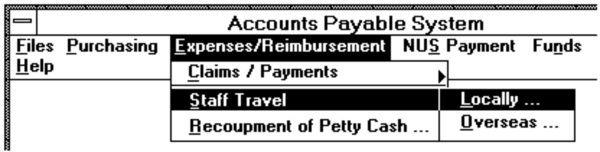
Figure 4.13.1: Dialog Box for Staff Travel
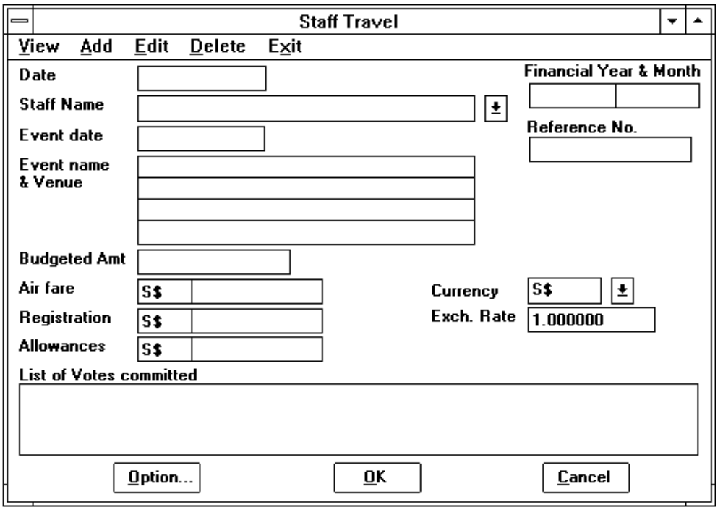

4.13.2 Contents.
1. Date.
Source: Mandatory entry for both 'Add' and 'Edit' commands. Displayed by the system for other commands.
Comment: Defaulted to the current system date.
2. Staff Name.
As described in Section 4.12.2.2 item 3.
3. Financial Year & Month.
As described in Section 4.12.2.1 item 3.
4. Reference No.
Source: Generated and displayed by the system.
Comment: The reference number is generated once the entry is confirmed to be accepted. It is prefixed by 'ST-' Eg. ST-999999.
5. Event date.
Source: Mandatory entry for both 'Add' and 'Edit' commands. Displayed by the system for other commands.
Comment: Defaulted to the current system date.
6. Event name/venue.
Source: Mandatory entry for both 'Add' and 'Edit' commands. Displayed by the system for other commands.
Comment: It is used to display or enter the name and venue of the event. It is 4 lines with 40 characters each.
7. Budgeted Amt.
Source: Mandatory entry for both 'Add' and 'Edit' commands. Displayed by the system for other commands.
Comment: Defaulted to the sum of air fare (item 8), registration (item 9) and allowances (item 10) in S$ equivalent.
8. Air Fare.
Source: Mandatory entry for both 'Add' and 'Edit' commands. Displayed by the system for other commands.
Comment: It is used to display or enter the air fare amount. There is a currency code 'S$' in front of it. The user is allowed to change the S$ currency to another when the course/seminar attended is held overseas. By default, it is zero for staff travel locally.
9. Registration.
Source: Mandatory entry for both 'Add' and 'Edit' commands. Displayed by the system for other commands.
Comment: It is used to display or enter the registration amount of the course/seminar. For detailed information, please refer to item 8.
10. Allowances.
Source: Mandatory entry for both 'Add' and 'Edit' commands. Displayed by the system for other commands.
Comment: It is used to display or enter the allowances claimed by the staff. For detailed information, please refer to item 8. By default, it is zero for staff travel locally.
11. Currency.
Source: Mandatory entry for both 'Add' and 'Edit' commands. Displayed by the system for other commands. It is visible when the user selects 'Overseas' command from the Staff Travel popup menu (Figure 4.13.1).
Comment: All the currencies will be displayed for the users to select. The default value is always 'S$'.
12. Exchange Rate.
Source: Mandatory entry for both 'Add' and 'Edit' commands. Displayed by the system for other commands.
Comment: By default, this value is 1.
13. List of Votes Committed.
Source: Displayed by the system.
Comment: The budgeted amount will be divided according to the cost centres which the staff are involved and displayed in this box. It consists of the cost centre description and the committed amount.
Eg. The budgeted amount is S$ 1000. The staff is in cost centres A, B & C.
Then the system will divide the budgeted amount equally and show in the box as follows:
Cost centre A 333.33
Cost centre B 333.33
Cost centre C 333.34
14. Option Button.
As described in Section 4.12.2.2 item 17.
15. OK Button.
As described in Section 4.2.3 item 7.
16. Cancel Button.
As described in Section 4.2.3 item 8.

4.13.3 Controls.
1. All the settled staff travel records are not allowed to be amended or deleted.
2. When deleting a record, a dialog box (Figure 4.2.2) is always displayed for the user to confirm whether the selected record should be deleted.

4.13.4 Error Messages.
1. This record already exists.
2. Please select a Staff !
3. Please select a currency code !
4. Please enter the Registration amount !
5. The exchange rate should be greater than 0 !
6. The date format should be 'dd/mm/yy' !
7. The month should be between 1 and 12 !
8. There is only nn days in that month !
(nn is the number of days of the month.)
9. Please enter the date again !

4.14 Recoupment of Petty Cash Dialog Box.

4.14.1 Purpose.
The users are able to update the petty cash reimbursed amount upon receiving the petty cash from the NUS Bursar's Office. The reimbursement dialog box is displayed when the user selects the 'Recoupment of Petty Cash' command from the Expenses menu (see Section 4.1.2).
Figure 4.14.1: Dialog Box for Recoupment of Petty Cash
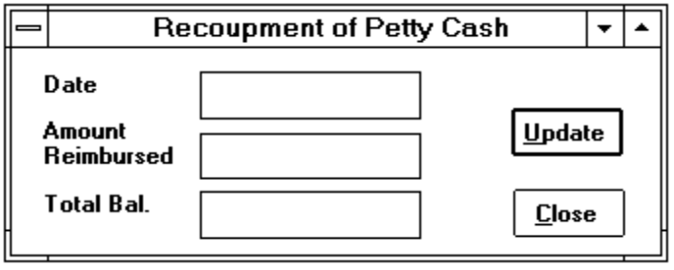

4.14.2 Contents.
1. Date.
Source: Mandatory entry for both 'Add' and 'Edit' commands. Displayed by the system for other commands.
Comment: Defaulted to the current system date.
2. Amount Reimbursed.
Source: Mandatory entry for both 'Add' and 'Edit' commands. Displayed by the system for other commands.
Comment: Defaulted to the current system date.
3. Total Bal.
Source: Generated and displayed by the system.
Comment: It is used to display the new balance of the petty cash in hand.
Total Bal. = Amount reimbursed (item 2) + Actual petty cash in hand
4. Update Button.
Source: It is used to confirm that the entries can be updated.
Comment: The entries will be updated if it is pressed.
5. Close Button.
Source: It is used to terminate the job and close the dialog box.
Comment: If this button is pressed, a message box will be displayed for user to confirm whether the entered amount reimbursed should be updated before terminating the job.

4.14.3 Control.
1. If the new petty cash balance shown in the Total Balance text box (item 3) is more than S$500.00, the system will not update the record.
2. A warning message will be displayed for user to confirm whether the entered amount reimbursed should be updated when the user presses the Close button without pressing the Update button.

4.14.4 Error Messages.
1. Please enter the amount !
2. The Petty cash balance is more than $500.00 !
3. The date format should be 'dd/mm/yy' !
4. The month should be between 1 and 12 !
5. There is only nn days in that month !
(nn is the number of days of the month.)
6. Please enter the date again !

4.15 Payments Dialog Boxes.

4.15.1 Purpose.
Due to different types of the expense payment, the system provides two categories of the NUS payment update such as Invoice Payments and Expenses Payments. The dialog boxes shown in Figure 4.15.1 and 4.15.2 will be displayed when the user selects the 'Invoice Payments' and 'Expenses Payments' commands from the NUS Payment menu (see Section 4.1.5) respectively. They allow users to update the actual cash payment made by the NUS Bursar's Office. A common command menu is displayed at the top of the dialog box for the users to select the command.
Figure 4.15.1: Dialog Box for Updating Cash Payment of Invoices
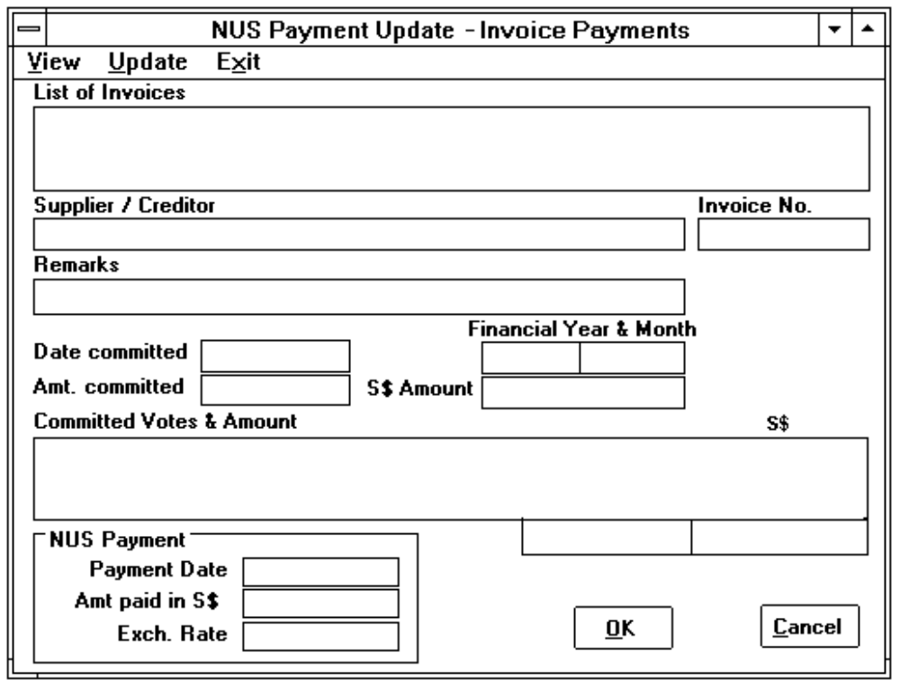
Figure 4.15.2: Dialog Box for Updating Cash Payment of Other Expenses
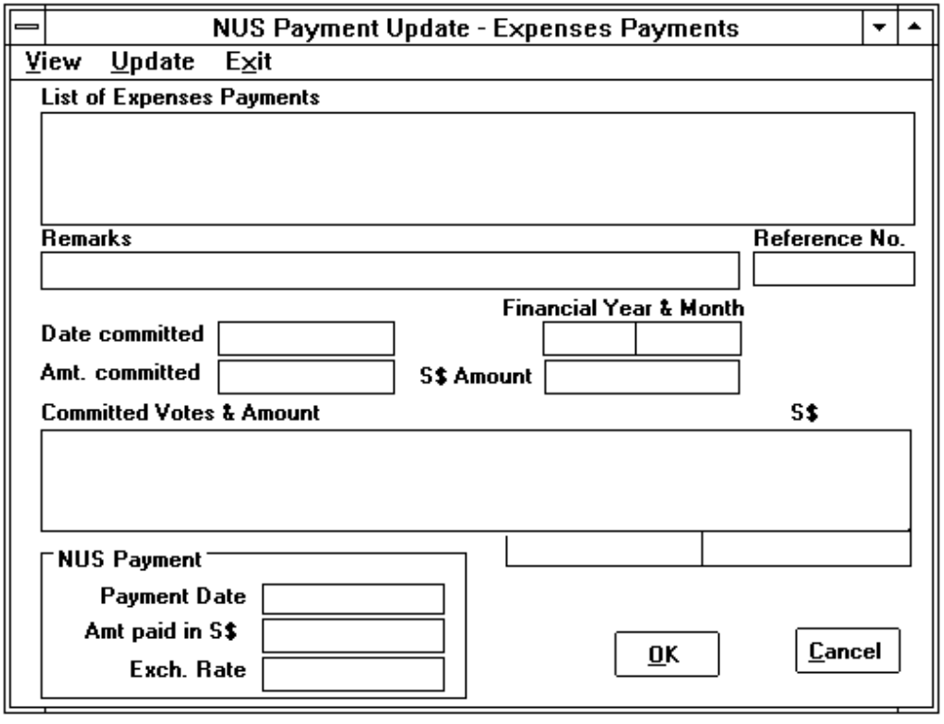

4.15.2 Command Menu.
View | To display the detailed information of the selected record.
Update | To update the record.
Exit | To close the dialog box and quits the job.

4.15.3 Contents.
1. List of Invoices.
Source: Displayed by the system for users to select a record to display or update.
Comment: It is only visible in the dialog box for updating cash payment of invoices (see Figure 4.15.1). Used to display all the invoices for the users to select. All records contain Invoice number followed by the date of invoice and the supplier's name.
2. List of Expenses Payments.
Source: Displayed by the system for users to select a record to display or update.
Comment: It is only visible in the dialog box for updating cash payment for other expenses (see Figure 4.15.2). Used to display all the expense payments records. All records contain reference number followed by the date claimed and remarks.
3. Supplier/Creditor.
Source: Displayed by the system
Comment: It is only visible in the dialog box for updating cash payment of invoices (see Figure 4.15.1). Used to display the name of supplier/creditor.
4. Invoice No.
Source: Displayed by the system
Comment: It is only visible in the dialog box for updating cash payment of invoices (see Figure 4.15.1). It is used to display the invoice number.
5. Reference No.
Source: Displayed by the system
Comment: Used to display the reference number. It is only visible in the dialog box for updating cash payment of invoices (see Figure 4.15.1).
6. Remarks.
Source: Displayed by the system
Comment: It is used to display the general description of the record.
7. Financial Year & Month.
Source: Displayed by the system
Comment: It is used to display the financial year & month.
8. Date committed.
Source: Displayed by the system
Comment: It is used to display the commitment date.
9. Amt committed.
Source: Displayed by the system
Comment: It is used to display the committed amount.
10. S$ Amount.
Source: Displayed by the system
Comment: It is used to display the S$ equivalent amount of the committed amount.
11. Committed Votes & Amount.
Source: Displayed by the system
Comment: It is used to display the funds committed by the selected invoice/expense payment. The records shown in box contains the Vote description, committed amount and amount in S$ equivalent. The total committed amount and the S$ equivalent amount are displayed below this box.
12. Payment Date.
Source: Mandatory entry for 'Update' command. Displayed by the system for 'View' commands.
Comment: Defaulted to the current system month and year. The format is 'MM/YY' Eg. 08/93 for August 1993.
13. Amt Paid in S$.
Source: Mandatory entry for 'Update' command. Displayed by the system for 'View' commands.
Comment: Defaulted to the S$ equivalent amount of committed amount (item 10).
14. Exchange Rate.
Source: Generated and displayed by the system
Comment: When the currency of the committed amount is an another currency (not 'S$') and the Amt Paid in S$ (item 13) is different from the S$ Amount (item 10), then this new exchange rate is computed and S$ equivalent committed amount of the individual votes involved will be updated automatically.
15. OK Button.
Source: It is used to confirm that the entries can be updated.
Comment: The entries will be updated if it is pressed.
16. Cancel Button.
Source: Optional push button. It is used to cancel the job.
Comment: The entries will not be updated if the user presses this button.

4.15.3 Control.
1. The amount paid in S$ should be always equal to the committed amount when the currency code is 'S$'.
2. The difference between the amount paid in S$ (item 13) and S$ amount (item 10) should be less than 1.
3. The year of the payment date (item 12) should be equal to the displayed financial year (item 7).

4.15.4 Error Messages.
1. Please enter the amount again. !
2. Please check this amount again !
3. Please enter the payment as mmyy, ie. 0593 !
4. Please check the year you have entered !
5. The month should be between 1 and 12 !

4.16 Funds Transfer Dialog Box.

4.16.1 Purpose.
Allows authorised users to transfer funds between votes or cost centres. The dialog box shown in Figure 4.16.1 is displayed when the user select 'Funds Transfer' command from the Funds menu (see Section 4.1.6).
Figure 4.16.1: Dialog Box for Funds Transfer
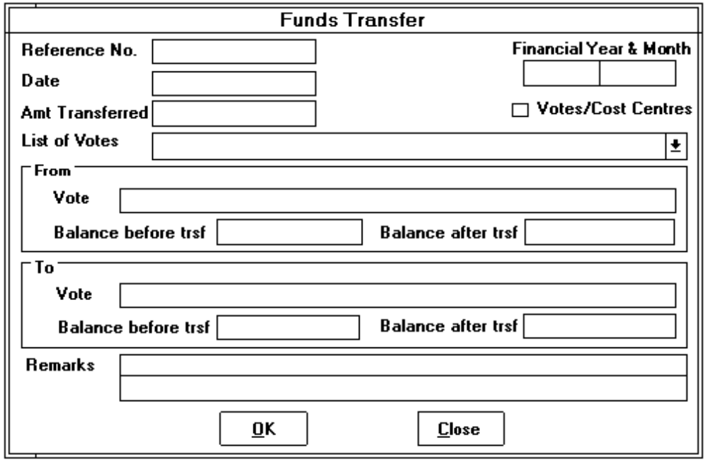

4.16.2 Contents.
1. Reference No.
Source: Generated and displayed by the system.
Comment: It is generated by the system when the entry is confirmed to be created. It is prefixed by 'TF-' Eg. TF-999999.
2. Financial Year & Month.
Source: Generated and displayed by the system.
Comment: Defaulted to the year and month of the accepted date (item 3).
3. Date.
Source: Mandatory entry.
Comment: Defaulted to the current system date.
4. Amt Transferred.
Source: Mandatory entry.
Comment: It is used to enter the amount to be transferred.
5. Votes/Cost Centres check box.
Source: Mandatory entry.
Comment: It is used to indicate whether it is a fund transfer between votes or cost centres. By default, it is a fund transfer between votes (the box is unchecked). For detailed information, please refer to item 6 & 7.
6. List of Votes.
Source: Displayed by the system. The title "List of Votes" will be changed to "List of Cost Centres" if the Vote/Cost Centres check box (item 5) is checked.
Comment: All the vote or cost centre records are displayed in this box for user to select. Please note that all the cost centres will be listed in this box when item 5 is checked.
7. Vote.
Source: Displayed by the system. The title "Vote" will be changed to "Cost Centre" if the Vote/Cost Centres check box (item 5) is checked.
Comment: It is used to display the selected vote/cost centre description.
8. Balance before trsf.
Source: Displayed by the system.
Comment: It is used to display the balance amount of the selected vote before funds transferred.
9. Balance after trsf.
Source: Displayed by the system.
Comment: It is used to display the balance amount of the selected vote after funds transferred.
10. Remarks.
Source: Mandatory entry.
Comment: It is used to enter the general purpose description of the record. Two lines with 40 characters each are provided.
11. OK Button.
As described in Section 4.15.2 item 15.
12. Cancel Button.
As described in Section 4.15.2 item 16.

4.16.3 Control.
1. Only the authorised users can perform this task.
2. The transferred amount should always be greater than zero.

4.16.4 Error Messages.
1. The date format should be 'dd/mm/yy' !
2. The month should be between 1 and 12 !
3. There is only nn days in that month !
(nn is the number of days of the month.)
4. Please enter the date again !
5. Please select a Vote !
6. Please enter the amount !

4.17 Journal Adjustment Dialog Box.

4.17.1 Purpose.
Allows users to create the journal adjustment entries to adjust the funds of the votes and update the monthly expenses of the votes that are directly paid by NUS Bursar's Office. The following dialog box (Figure 4.17.1) will be displayed when the user selects the 'Journal Adjustment' command from the Funds menu (see Section 4.1.5). For detailed information about the command menu displayed at top of the dialog box, please refer to Section 4.17.2.
Figure 4.17.1: Dialog Box for Journal Adjustment
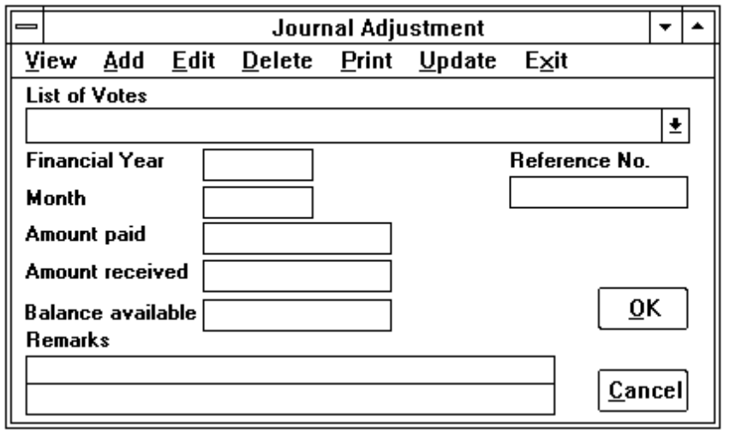

4.17.2 Command Menu.
View | To display the detailed information of the selected record.
Add | To create new record.
Edit | To edit the selected journal adjustment record.
Delete | To delete the selected journal adjustment record.
Print | To print a list of the created journal adjustment records. Refer to Section 5.12.
Update | To update the created journal adjustment records.
Exit | To close the dialog box and quits the job.

4.17.3 Contents.
1. List of Votes.
Source: Displayed by the system.
Comment: All the vote records are displayed for users to select.
2. Financial Year.
Source: Mandatory entry for 'Add' and 'Edit' commands. Displayed by the system for 'View' and 'Delete' commands.
Comment: Defaulted to the year of the current system date.
3. Month.
Source: Mandatory entry for 'Add' and 'Edit' commands. Displayed by the system for 'View' and 'Delete' commands.
Comment: Defaulted to the month of the current system date.
4. Reference No.
Source: Mandatory entry for 'Add' and 'Edit' commands. Displayed by the system for 'View' and 'Delete' commands.
Comment: It is used to display or enter the journal voucher number.
5. Amount Paid.
Source: Mandatory entry for 'Add' and 'Edit' commands. Displayed by the system for 'View' and 'Delete' commands.
Comment: It is used to enter or display the amount paid.
6. Amount Received.
Source: Mandatory entry for 'Add' and 'Edit' commands. Displayed by the system for 'View' and 'Delete' commands.
Comment: It is used to enter or display the received amount.
7. Balance available.
Source: Generate and displayed by the system.
Comment: It is used to display the balance amount of the selected vote.
8. Remarks.
Source: Mandatory entry for 'Add' and 'Edit' commands. Displayed by the system for 'View' and 'Delete' commands.
Comment: It is used to enter or display the general purpose description of the record. Two line with 40 characters each are provided.
9. OK Button.
As described in Section 4.15.2 item 15.
10. Cancel Button.
As described in Section 4.15.2 item 16.

4.17.3 Control.
1. Only the authorised users are allowed to perform the update command.
2. The users are not allowed to delete a updated journal adjustment records.
3. When deleting a journal entry that has not been updated, a dialog box (Figure 4.2.2) is displayed for the user to confirm whether the selected record should be deleted.

4.17.4 Error Messages.
1. The record already exists !
2. Please enter the Reference No. !
3. Please select a Vote !
4. Please enter the amount again !
5. You have to enter at least one of the amount (either amount received or amount paid) !
6. The month should be between 1 and 12 !
7. Please check the year you have entered !

4.18 Financial Year Budget Dialog Box.

4.18.1 Purpose.
Allows authorised users to prepare the budget accounts for a financial year. The dialog box shown in Figure 4.18.1 will be displayed when the user selects 'Budget Accounts' command from Funds menu. For more information about the command menu displayed at top of the dialog box, please refer to Section 4.2.2.

4.18.2 Contents.
1. List of Votes.
Source: Displayed by the system.
Comment: All the vote records are displayed in this box for the user to select.
Figure 4.18.1: Budget Accounts Dialog Box
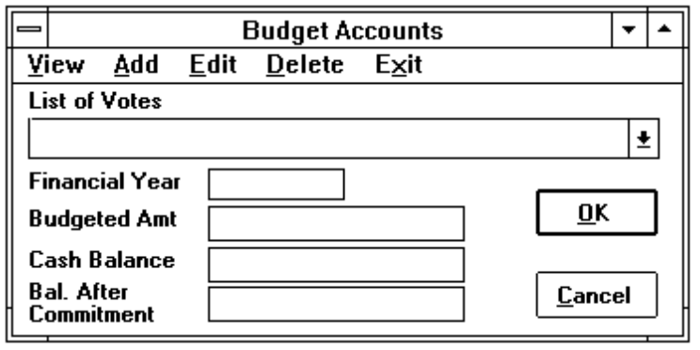
2. Financial Year.
Source: Mandatory entry for 'Add' and 'Edit' commands. Displayed by the system for other commands.
Comment: Defaulted to the year of the current system date.
3. Budgeted amount
Source: Mandatory entry for 'Add' and 'Edit' commands. Displayed by the system for other commands.
Comment: It is used to display or enter the budgeted amount of the selected vote.
4. Cash Balance.
Source: Displayed by the system.
Comment: It is used to display the actual cash balance. Defaulted to the budgeted amount (item 3).
5. Balance after commitment
Source: Displayed by the system.
Comment: It is used to display the balance after commitment. Defaulted to the budgeted amount (item 3).
6. OK Button.
As described in Section 4.15.2 item 15.
7. Cancel Button.
As described in Section 4.15.2 item 16.

4.18.3 Control.
1. Only authorised users are allowed to perform this task.
2. When deleting a record with no fund commitment, a dialog box (Figure 4.2.2) is displayed for the user to confirm whether the selected record should be deleted.

4.18.4 Error Messages.
1. Please select a Vote !
2. Please enter the amount !
3. Please check the year you have entered !

4.19 Staff Information Dialog Box.

4.19.1 Purpose.
Allows authorised users to create new staff records and edit the existing staff records. The following dialog box is displayed when the user presses the 'Option' button from the Claims for Subscription to Professional Societies dialog box (Figure 4.12.3) or Staff Travel dialog box (Figure 4.13.1).
Figure 4.19.1: Dialog Box for maintaining Staff Information
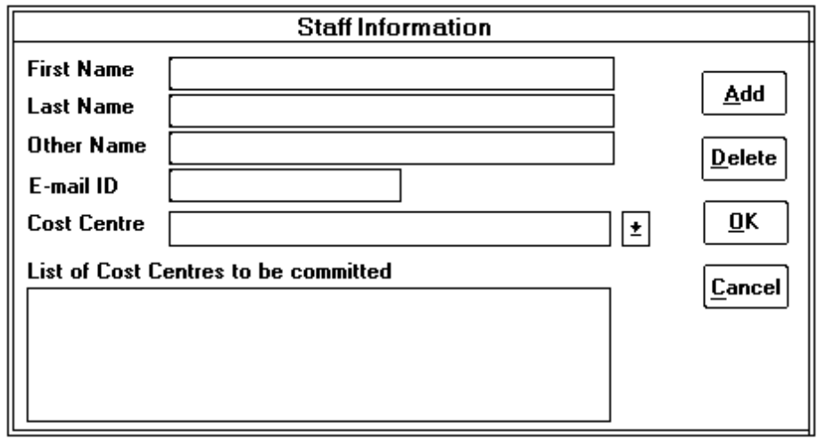

4.19.2 Contents.
1. First Name.
Source: Mandatory entry for new staff.
Comment: First name is part of the staff name that is the combination of other name, first name and last name. If the user selects a staff from the Staff list box in dialog boxes shown in Figure 4.12.3 and 4.13.1, the first name of the selected staff name is displayed in this text box.
2. Last Name.
Source: Mandatory entry for new staff.
Comment: Used to display or enter the last name of a staff. For more detailed information, please refer to item 1.
3. Other Name.
Source: Mandatory entry for new staff.
Comment: Used to display or enter the other name of a staff. For more detailed information, please refer to item 1.
4. E-mail ID.
Source: Mandatory entry for new staff.
Comment: Used to display or enter the E-mail ID of the staff.
5. Cost Centre.
Source: Displayed by the system.
Comment: All the cost centres will be displayed for user to select.
6. List of Cost Centres to be committed.
Source: Generated and displayed by the system.
Comment: If the 'Add' button (see item 7) is pressed, the selected cost centre will be shown in this box. It means that all the expenditure of this staff will be charged to the selected cost centre.
7. Add Button.
Source: It is an optional push button.
Comment: This button will be visible when the user selects a cost centre from the Cost Centre list box (item 5). If this button is pressed, the selected cost centre is shown in the List of Cost Centres to be committed list box (see item 6).
8. Delete Button.
Source: It is an optional push button.
Comment: This button will be visible when the user clicks on a cost centre from the List of Cost Centres to be committed (item 6). If this button is pressed, the selected cost centre will be removed.
9. OK Button.
Source: It is used to confirm that all the entries that are correct. The record will be updated later.
Comment: The dialog box will be closed and control will return to the previous dialog box when this button is pressed.
10. Cancel Button.
Source: Optional push button. It is used to cancel the job.
Comment: The dialog box will be closed and return to the previous dialog box when this button is pressed. However, the amended entries will not be updated.

4.19.3 Control.
1. The system will not allow more than one staff member to have the same name.
2. At least one cost centre should be assigned to the staff.

4.19.4 Error Messages.
1. The record already exists !
2. You have to select at least one cost centre !

4.20 Common Dialog Box for Displaying List of Records.

4.20.1 Purpose.
The common dialog box (Figure 4.20.1) is used in many parts of the system for displaying a list of records such as purchase orders, delivery orders, invoices & etc. for the users to select, so that the detailed information of the selected record can be printed or displayed. In this example, a list of purchase orders are displayed for the user to select for updating the delivery order to the selected purchase order.
Figure 4.20.1: Common Dialog Box
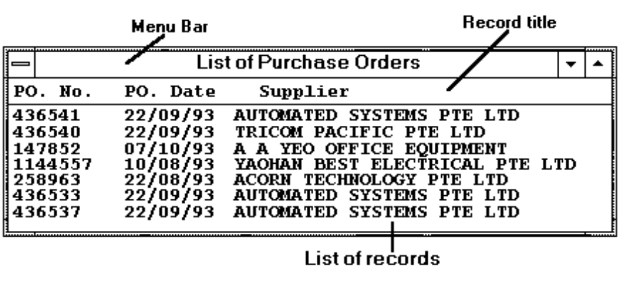

4.20.2 Contents.
1. Menu Bar.
The menu bar is used to indicate the name of the records displayed Eg. List of Purchase Orders.
2. Record title.
The title of each record item is shown in this area Eg PO No, PO Date and Supplier.
3. List of records.
All the specified records are shown in this box. The detailed information of a records can be displayed or printed when the user clicks on it.

5. REPORT FORMATS.
All the reports provided by the system are described in this section. Report formats are shown on Appendix A.

5.1 Purchase Order Transactions.

5.1.1 Purpose.
To provide a list of the purchase order transactions for Admin. staff to check and file.

5.1.2 Format.
Refer to Appendix A/2.

5.1.3 Form.
Normal computer form.

5.1.4 Frequency.
Daily or as and when required.

5.1.5 Sorting Sequence.
Printed in the ascending order of PO number.

5.1.6 Comments.
A total of the PO amount in S$ equivalent is printed at the end of the report.

5.2 Received Invoice Transactions.

5.2.1 Purpose.
To provide a list of the received invoice transactions for Admin. staff to check and file.

5.2.2 Format.
Refer to Appendix A/3.

5.2.3 Form.
Normal computer form.

5.2.4 Frequency.
Daily or as and when required.

5.2.5 Sorting Sequence.
It can be printed in the ascending order of PO number or the suppliers' name.

5.2.6 Comments.
A total of the invoice amount in S$ equivalent is printed at the end of the report.

5.3 Petty Cash Transactions.

5.3.1 Purpose.
To provide a list of the petty cash transactions for off-line reference. It is also used to submit to the NUS Bursar's Office for petty cash reimbursement purposes.

5.3.2 Format.
Refer to Appendix A/4.

5.3.3 Form.
Normal computer form.

5.3.4 Frequency.
Monthly or as and when required.

5.3.5 Sorting Sequence.
Printed in the ascending order of transaction date.

5.3.6 Comments.
A summary of each vote total is provided at the end of the report.

5.4 Claims/Expense Payment Transactions.

5.4.1 Purpose.
To provide a list of the claims/expense payment transactions for off-line reference.

5.4.2 Format.
Refer to Appendix A/5.

5.4.2 Form.
Normal computer form.

5.4.3 Frequency.
Daily or as and when required.

5.4.5 Sorting Sequence.
Printed in the ascending order of transaction date.

5.4.6 Comments.
A total of the transaction amount in S$ equivalent is printed at the end of the report.

5.5 Claims for Professional Societies Subscription - Letter to Bursar's Office.

5.5.1 Purpose.
It is used to notify the NUS Bursar's Office to make payment to the staff for the claims requested.

5.5.2 Format.
Refer to Appendix A/6.

5.5.3 Form.
ISS Letter head (A4 size).

5.5.4 Frequency.
Daily or as and when required.

5.6 Claims for Subscription to Professional Societies Report.

5.6.1 Purpose.
To provide a list of the claims for subscription to professional societies of the staff for off-line reference.

5.6.2 Format.
Refer to Appendix A/7.

5.6.3 Form.
A4 size paper.

5.6.4 Frequency.
Ad hoc statement.

5.6.5 Sorting Sequence.
Printed in the ascending order of the staff name.

5.7 Staff Travelling.

5.7.1 Purpose.
To provide a list of the staff travelling records for off-line reference.

5.7.2 Format.
Refer to Appendix A/8.

5.7.3 Form.
Normal computer form.

5.7.4 Frequency.
Daily or as and when required.

5.7.5 Sorting Sequence.
Printed in the ascending order of the vote description and staff name.

5.7.6 Comments.
A total of the amount paid is printed at the end of the report.

5.8 Unsettled Payable Accounts.

5.8.1 Purpose.
To show a list of the unsettled invoice transactions for account reconciliation and off-line reference.

5.8.2 Format.
Refer to Appendix A/9.

5.8.3 Form.
Normal computer form.

5.8.4 Frequency.
Ad hoc report.

5.8.5 Sorting Sequence.
It can be printed in the ascending order of the PO number or the suppliers' name.

5.8.6 Comments.
A total of the invoice amount in S$ equivalent is printed at the end of the report.

5.9 Vote Control Register.

5.9.1 Purpose.
To show all the detailed transactions of each vote account for off-line reference and audit purpose.

5.9.2 Format.
Refer to Appendix A/10.

5.9.3 Form.
Normal computer form.

5.9.4 Frequency.
Ad hoc report.

5.9.5 Sorting Sequence.
Printed in the ascending order of the vote account and the transaction date.

5.9.6 Comments.
A total of the commitment amount (in S$ equivalent), balance available, invoice amount, cash payment amount and the cash balance available is printed at the end of each vote account.

5.10 Total Accumulated Expenditure.

5.10.1 Purpose.
To show a list of all the accumulated expenditure for off-line reference.

5.10.2 Format.
Refer to Appendix A/11.

5.10.3 Form.
Normal computer form.

5.10.4 Frequency.
Ad hoc report.

5.10.5 Sorting Sequence.
Printed in the ascending order of the vote description.

5.10.6 Comments.
A total of the commitment amount of each cost centre is printed at the end of the report.

5.11 Journal Adjustment Transactions.

5.11.1 Purpose.
To provide a list of the journal adjustment transactions for Admin. staff to check and file.

5.11.2 Format.
Refer to Appendix A/12.

5.11.3 Form.
Normal computer form.

5.11.4 Frequency.
Daily or as and when required.

5.11.5 Sorting Sequence.
Printed in the ascending order of the vote description.

5.11.6 Comments.
The amount available of each vote account is printed at the end of each vote account.

5.12 Cancellation of POs Transactions.

5.12.1 Purpose.
To provide a list of the cancellation of POs transactions for off-line reference

5.12.2 Format.
Refer to Appendix A/13.

5.12.3 Form.
Normal computer form.

5.12.4 Frequency.
Daily or as and when required.

5.12.5 Sorting Sequence.
Printed in the ascending order of the PO number.

5.12.6 Comments.
A total of the cancelled amount in S$ equivalent is printed at the end of the report.

5.13 Audit Trail reports.

5.13.1 Purpose.
To provide a list of the amended/deleted transactions for audit trail purposes.

5.13.2 Format.
Refer to Appendix A/14.

5.13.3 Form.
Normal computer form.

5.13.4 Frequency.
Ad hoc reports.

5.13.5 Sorting Sequence.
Printed in the ascending order of the reference number.

5.14 Currency Exchange Rate.

5.14.1 Purpose.
To provide a list of the currency exchange rate for off-line reference.

5.14.2 Format.
Refer to Appendix A/15.

5.14.2 Form.
A4 size paper.

5.14.3 Frequency.
Monthly or as and when required.

5.14.4 Sorting Sequence.
Printed in the ascending order of the currency code.

6. SECURITY.
For the security control purpose, this system is only accessible by the specified types of user with the assigned permissions. The types of user and their access requirements are defined as follows:
1. Day-to-Day Function User (Lek Hoi and Kim Fong).
These users should have access to the following functions:
• Purchasing Orders
• Delivery Orders
• Invoices
• Payments
• Petty Cash and Claims
• Staff Travel Expenses
2. Library Functions User (Soo and Gillian).
These users should have access to the following functions that are related to the Resourse Centre
• Purchasing Orders
• Delivery Orders
• Invoices
• Payments
In additon to these, they should be able to view the fund of the Resource Centre Vote
3. Admin. Officer (Geok Tin).
She should have access to all functions except for those related to altering the budgets.
4. Admin. Manager (Wee Li).
She should have access to all functions.

Appendix A : REPORT FORMATS.
The purpose of this appendix is to show samples of the report formats that will be produced by the system. They are as follows :
1. Purchase Order Transactions
2. Received Invoice Transactions
3. Petty Cash Transactions
4. Claims/Expense Payment Transactions.
5. Claims for Subscription to Professional Societies
5.1 Letter to Bursar's Office
5.2. Transactions Report
6. Staff Travelling
7. Unsettled Payable Accounts
8. Vote Control Register
9. Total Accumulated Expenditure
10. Journal Adjustment Transactions
11. Cancellation of POs Transactions
12. Audit Trail Report
13. Currency exchange Rate
99.99.99 - 99.99.99 Purchase Order Transactions Page 9999
Date 99/99/99
Time 99:99:99
PO & Pre-
PO Date PRF NO. Supplier & Description Amount D/O No. D/O Date Invoice No. Pymt
99/99/99 *--------* *-------------------------------* ***999999,999.99 *-------------* 99/99/99 *-------------* *
*--------* *-------------------------------* S$ 999,999.99
*-------------------------------*
99/99/99 *--------* *-------------------------------* ***999999,999.99 *-------------* 99/99/99 *-------------* *
*--------* *-------------------------------* S$ 999,999.99
*-------------------------------*
:
:
Total S$ 9999,999.99
********** End of Report **********

99.99.99 - 99.99.99 Received Invoice Transactions Page 9999
Date 99/99/99
Time 99:99:99
<-------Invoice--------> <---PO / DO---> Invoice Date Sent Payment
No. Date No. & Date Supplier & Description Amount S$ Amount to Bursar Date
*-------------* 99/99/99 *-------------* *--------------------------------------* ***999,999,999.99 999,999,999.99 99/99/99 99/99/99
99/99/99 *--------------------------------------*
99/99/99 *--------------------------------------*
*-------------* 99/99/99 *-------------* *--------------------------------------* ***999,999,999.99 999,999,999.99 99/99/99 99/99/99
99/99/99 *--------------------------------------*
99/99/99 *--------------------------------------*
:
:
:
Total 99,999,999.99
********** End of Report **********
99.99.99 - 99.99.99 Petty Cash Transactions Page 9999
Date 99/99/99
Time 99:99:99
Voucher Office Revolving Cash
Date Description No. Postage Travelling Supplies Fund Misc. in hand
99/99/99 *----------------------------* *--------* 999.99 999.99 999.99 999.99 999.99 999.99
*----------------------------* *-------------* *-------------* *-------------* *-------------*
99/99/99 *----------------------------* *--------* 999.99 999.99 999.99 999.99 999.99 999.99
*----------------------------* *-------------* *-------------* *-------------* *-------------*
: : : : : :
--------------------------------------------------------------------------------
Total 999.99 999.99 999.99 999.99 999.99 999.99
================================================================================
Summary:
<------------Program Description----------> Amount
*----------Vote Description----------*
*----------* *----------------------------* 999.99
:
Total 999.99
*----------Vote Description----------*
*----------* *----------------------------* 999.99
:
Total 999.99
*** Total Amount to be reimbursed = S$ 999.99
********** End of Report **********

99.99.99 - 99.99.99 Claims / Expense Payment Transactions Page 9999
Date 99/99/99
Time 99:99:99
Reference <---------------Commitment--------------> Cash Paymt
Date & Claim No. Description Amount Vote Description Amount Date
99/99/99 *--------* *--------------------------------------* ***999,999.99 *----------------------------* 999,999.99 99/99
*--------* S$ 999,999.99 *----------------------------* 999,999.99
99/99/99 *--------* *--------------------------------------* ***999,999.99 *----------------------------* 999,999.99 99/99
*--------* S$ 999,999.99 *----------------------------* 999,999.99
:
:
:
Total S$ 999,999.99
********** End of Report **********
99 *** 99
Miss Patricia Choo
Bursar's Office
National University of Singapore
REIMBURSEMENT
Please reimburse the following in cash begin claims for subscription to Professional
societies. Receipts are attached.
Name Society Amount Vote
*------------------------------* *----------* S$999.99 *---------------------------*
*---------------------------*
*------------------------------* *----------* S$999.99 *---------------------------*
*---------------------------*
:
:
Lian Wee Li (Miss)
Manager, Administration
for Director

Claims for Subscription to Professional Societies Page 9999
From 99/99/99 to 99/99/99 Date 99/99/99
Professional Period of Subscription Amount
Name Society Membership Amount Claimed Date
*----------------------------* *--------* 9999 *** 9999.99 S$ 999.99 99/99/99
*----------------------------* *--------* 9999 *** 9999.99 S$ 999.99 99/99/99
:
:
:
Total S$99,999.99
********** End of Report **********

Staff Travelling Page 9999
Date 99/99/99
Time 99:99:99
*------Vote Description---------*
<----------------Actual----------------->
Estimated Registration Total
<-----------Staff----------> Date <------------Event-----------> Expenses Air Fare Fee Allowances Amt Paid

*--------------------------* 99/99/99 *----------------------------* 999,999.99 ***999,999.99 ***999,999.99 ***999,999.99 999,999.99
*----------------------------*
*----------------------------*
*----------------------------*
*--------------------------* 99/99/99 *----------------------------* 999,999.99 ***999,999.99 ***999,999.99 ***999,999.99 999,999.99
*----------------------------*
*----------------------------*
*----------------------------*
:
:
Total 999,999.99
********** End of Report **********

Unsettled Payable Accounts Page 9999
Date 99/99/99
Time 99:99:99
<------PO & DO------> <--------Invoice-------> Date sent
No. Date Supplier & Description Amount S$ Amount No. Date to Bursar
P *--------* 99/99/99 *--------------------------------------* ***999,999,999.99 999,999,999.99 *-------------* 99/99/99 99/99/99
D *--------* 99/99/99 *--------------------------------------*
Prf # *--------* *--------------------------------------*
P *--------* 99/99/99 *--------------------------------------* ***999,999,999.99 999,999,999.99 *-------------* 99/99/99 99/99/99
D *--------* 99/99/99 *--------------------------------------*
Prf # *--------* *--------------------------------------*
:
:
:
Total 999,999,999.99
********** End of Report **********

Vote Control Register Page 9999
Date 99/99/99
Time 99:99:99
Vote : *---vote no.-----* *----vote description-----------* Budgeted amount : S$ 999,999,999.99
Funds
Ref. No. Commitment Program Balance <-----Invoice----> Bal to be Surplus/ Date sent Paymt
/PO. No. Date Supplier & Description Chargeable Amount Available Date/No. Amount Paid (Deficit) to Bursar Date
*----------* 99/99/99 *-------------------------* *---------------* 999999.99 999999.99 99/99/99 999999.99 999999.99 (9999.99) 99/99/99 99/99
*----------* *-------------------------* *--------* *---------------------*
*-------------------------*
*----------* 99/99/99 *-------------------------* *---------------* 999999.99 999999.99 99/99/99 999999.99 999999.99 (9999.99) 99/99/99 99/99
*----------* *-------------------------* *--------* *---------------------*
*-------------------------*
: : : : :
: : : : :
: : : : :
999999.99 999999.99 999999.99 999999.99 (9999.99)
********** End of Report **********

Total Accumulated Expenditure as at 99/99/99 Page 9999
(ATA/RND/ISS APPLE/Institution) Date 99/99/99
Time 99:99:99
*-vote A/C No-* *-vote A/C No-* *-vote A/C No-* *-vote A/C No-* *-vote A/C No-* Budgeted
Vote Description *-prog. title-* *-prog. title-* *-prog. title-* *-prog. title-* *-prog. title-* Expenditure Amount Balance
*--------------* 999,999,999.99 999,999,999.99 999,999,999.99 999,999,999.99 999,999,999.99 99,999,999.99 99,999,999.99 99,999,999.99
*--------------* 999,999,999.99 999,999,999.99 999,999,999.99 999,999,999.99 999,999,999.99 99,999,999.99 99,999,999.99 99,999,999.99
: :
: :
Total OOE 999,999,999.99 999,999,999.99 999,999,999.99 999,999,999.99 999,999,999.99 99,999,999.99 99,999,999.99 99,999,999.99
********** End of Report **********
JOURNAL ADJUSTMENTS TRANSACTIONS PAGE 9999
DATE 99/99/99
TIME 99:99:99
DATE REFERENCE # AMT REC'D AMT PAID NET AMT. REMARKS
*----------Vote description------------* 9,999,999.99
99/99/99 *--------* 9,999,999.99 9,999,999.99 9,999,999.99 *-------------------------------------*
*-------------------------------------*
99/99/99 *--------* 9,999,999.99 9,999,999.99 9,999,999.99 *-------------------------------------*
*-------------------------------------*
:
:
Amount available 9,999,999.99
*----------Vote description------------* 9,999,999.99
99/99/99 *--------* 9,999,999.99 9,999,999.99 9,999,999.99 *-------------------------------------*
*-------------------------------------*
99/99/99 *--------* 9,999,999.99 9,999,999.99 9,999,999.99 *-------------------------------------*
*-------------------------------------*
:
:
Amount available 9,999,999.99
********** END OF REPORT **********

99.99.99 - 99.99.99 Cancellation Of POs Transactions Page 9999
Date 99/99/99
Time 99:99:99
PO PO & Amount <---Cancellation of Funds Committed---> Date
Date Requisit.NO. Supplier & Description PO Amount Cancelled Vote Description Amount Cancelled
99/99/99 *--------* *-----------------------------* ***999,999.99 999,999.99 *--------------------------* 999,999.99 99/99/99
*--------* *-----------------------------* S$ 999,999.99 999,999.99 *--------------------------* 999,999.99
*-----------------------------* *--------------------------* 999,999.99
99/99/99 *--------* *-----------------------------* ***999,999.99 999,999.99 *--------------------------* 999,999.99 99/99/99
*--------* *-----------------------------* S$ 999,999.99 999,999.99 *--------------------------* 999,999.99
*-----------------------------* *--------------------------* 999,999.99
:
:
Total S$ 9999,999.99
********** End of Report **********

99.99.99 - 99.99.99 Audit Trail Report Page 9999
Date 99/99/99
Time 99:99:99
Amount
Date Ref. No. Record Type Committed User ID Remarks
99/99/99 *--------* *------------------* *** 999,999.99 *--------* *--------------------------------------*
99/99/99 *--------* *------------------* *** 999,999.99 *--------* *--------------------------------------*
:
:
:
********** End of Report **********

Currency Exchange Rate Page 9999
Date 99/99/99
Time 99:99:99
For the period : *----------------*
Currency Code Exchange Rate
*** 999.999999
*** 999.999999
: :
: :
: :
********** End of Report **********

Approval Record ISS/Forms/Approval

Project Name FCS Accounts Payable Project
Document Ref ISS/FCS2/TS.2/1
Approved by | Date
Authorised by | Date
The document authorisation appears on the title page.
The structure of the publication is logical.
The distribution list is correct.
The title page is signed.
Calculations appear reasonable, are neatly presented and have been checked.
Theory and formulae are correct and properly applied.
Illustrations are relevant, readable and logically placed.
There are no typographical errors.
Units are consistent throughout.
The security classification is correct.
There are no obvious omissions.
The document complies with the Client's requirements, however specified.
Responsibility is accepted for all opinions, conclusions and recommendations.
The document does not run counter to company policy.

